# **Notes on Perspective**

An application that visually reconstructs the thoughts and feelings which occurred during a classical musical performance

temporal data embodied time experienced time data visualization

## **Abstract**

Notes on Perspective is an application that visually reconstructs the thoughts and feelings which occurred during a classical musical critique at the Mannes School of Music in New York City. It experiments with making visually tangible and beautiful the thoughts and feelings that occured during this musical performance among the ensemble members. It is built as a single page application (SPA) with three states. Each state visually experiments with binding data to an abstraction of embodied experience: 1) situatedness, 2) activity and 3) perception. It visualizes a color score by clustering the musical score being performed by musical notation and sequential progression. Notes on Perspective acknowledges the shortcomings of digital artifacts in replicating lived experience, attempting to playfully humanize temporal data, bringing information to life. This approach to embodied data visualizations for temporal data is referred to as designing in Kairos.

## 

## Table of Contents

Notes on Perspective

Abstract

Table of Contents

I. About the Project

About the Data Visualization

About the Data

On the Design Methodology

Approaches Examined in this Data Visualization

Contents of Paper

II. Data Visualization in Kairos

Why Design Data Visualizations in Kairos?

Representation of Time

How do we currently see time?

Knowing absolute time

Experiencing relative time

III. Designing an Embodied Experience from Temporal Data

Embodied Cognition

When Embodied Experience is Cognitively Modified

When Embodied Experience is less Cognitively Modified

Binding Elements of Embodied Experience to Different Application States

Reconstructing Musical Performances From The Original Listening Environment

IV. Literature Review (Precedents)

A first in interactive multi-dimensional experiences

Multi-dimensional experiences from more than 2 perspectives

Creating embodied experiences using multi-dimensional data

Signature Moments in Data

Giorgia Lupi

Valentina D'EFilippo

Histography.io by Matan Stauber

50 Years Swiss Music Charts by D|One

Reimagine the Game by the Economist

One Angry Bird by Periscopic

V. Design & Development Process

Prototyping

A simple wireframe was created to identify the most essential components for the visualization and inform a pathway for the ground build.

Data Structure

Build

Design Principles & User Experience

Exploratory Data Visualization Findings

Prototypes Designed

Final Data Visualization

Limitations and Continuing Research

Issues and Limitations of Visualizing Kairos

V. Conclusion

## 

## **I. About the Project**

### About the Data Visualization

Notes on Perspective is a data visualization that experiments with designing temporal data in embodied time. It aims to reconstruct event data in embodied time by complementing chronometrical representations of time (chronos) with the sensorial inputs of experienced time (kairos). The intention is to use affordances of the digital medium to design data back to life, particularly when visualizing qualitative data collected from humans such as thoughts and feelings. Notes on Perspective focuses on three elements of experienced time as an entry-point into this approach to data visualization: 1) situatedness, 2) relative activity occurring in absolute time and 3) perception of events in time. Findings are taken from the fields of data visualization, human-computer interaction (HCI), human-media interaction, anthropology, cognitive science and philosophy. The paper will identify precedents in the digital medium, from interactive sculptures and mixed reality to infographics, for embodying and encoding narrative from multiple perspectives to elicit awe, presence and other affect responses comparable to how humans process information during lived experience.

### About the Data

The data was generously provided by Michael Schober and Neta Spiro from their research study on shared attention *“Classical chamber musicians’ shared understanding: A case study.”* Data was collected during a recital critique at the Mannes School of Music between 14 ensemble members studying Fantasiestücke Opus 73 by Robert Schumann. As class members reacted to the performance, comments were recorded and reviewed by at least two other class members. The researchers then categorized each reaction by sentiment (positive, negative or neutral/mixed) as well as musical subject matter (i.e. tempo, balance, dynamics, rhythmic motion, character).

**Dataset Selection**

The dataset was selected as an ideal candidate for kairos design due to:

* The cleanliness of data captured from well-defined perspectives or roles (performers, audience, back-up performers)
* The encapsulation of data in a demarcated space and time (i.e. clear beginning and end with reactions that can be tied to an identifiable moments in time)
* Using what is readily understood as an event (i.e. a musical performance)

Notes on Perspective is both a data visualization on reconstructing an event in embodied time as well as a vehicle for visualizing the research study findings in shared attention. To the latter end, it visually illustrates phenomena such as 1) integrative attention, which is the monitoring of one’s own personal judgment above others while monitoring the overall moment and 2) adaptive timing, or adjusting one’s moments in response to unanticipated changes in the event (Keller 2008, 205-221).

### On the Design Methodology

Notes on Perspective is built with Javascript as a single page application (SPA). D3.js was used for its data visualization functions. Python was used for data re-structuring and running the machine learning model to cluster each beat of the performance by similarity. The design process broadly encompasses the following steps:

* **Exploration & Analysis:** This involved exploring connections between the data and developing a preliminary build to test those connections. For example, images of each beat in the musical score were connected to the timestamp in the audio recording of the performance, as well as a measure and beat identifier, which was used to pull comments that occurred during that moment by sentiment and musical subject matter.
* **Design Research & Establishing Goals***:* Opportunities for sensory reconstruction were identified through research and finding precedents for the techniques employed in Notes on Perspective. This includes for example, creating an interface for embodied data, handling multidimensional data, and designing data signatures.
* **Data Architecture & Wireframes + Prototypes:**A sequence of design prototypes were created, which informed the final design by providing alternatives for design elements. The data structure and architecture was also mapped out during this stage to inform production.
* **Staging & Production:**Final staging and production of design and engineering as a single page application developed in javascript was accomplished during this stage. This phase also included rounds of peer and professional critique to continually refine the project.

### Approaches Examined in this Data Visualization

The following approaches, through the way they build new possibilities to experience and traverse data points in space-time, or offer visual alternatives to read a recaptured analysis of sentiment occurring over time, have been selected as points of departure for designing data visualizations in kairos.

**Embodied Data**

Reconstructing data points captured during an event tangible and sensorial. Questions asked include: How can sentiment data be reconstructed as information that viewers directly interpret as feelings? How can real-time thoughts and responses be directly passed to participants? How can environmental cues that are critical to the context in which event data is mined from be reconstructed to help interactors re-constructing the event in a digital medium better understand the situated nature of the data?

**Multidimensional Data**

Displaying the multiplicity of data from different perspectives in alternative views or angles. Primary question asked: How can we take advantage of the encyclopedic and spatial affordances of the digital medium to provide insightful access to event data in a digital reconstruction?

**Signature Moments in Data**

Using visual metaphors in data visualization to contain unique signatures, or combinations of important attributes and variables, in the data. Primary question asked: How can we take advantage of how affect modifies cognition and directs attention to strengthen memory and recall to give individuals interacting with the reconstructed event an experienced impression of what occurred by travelling through it visually?

### Contents of Paper

This paper focuses on the design research of visualizing temporal data from an event. It will discuss how we’ve historically arrived at chronometrical representations of time and propose paths forward for understanding experienced time. It will define what an “event” means and confront the challenges that temporal data collected from an event faces when being reconstructed in the digital medium. From there, affordances and possibilities for enriching the interpretation of temporal data from an event will be explored from data visualization design precedents as well as research from biology, philosophy, social sciences, computer science and the arts.

A treatment on the the methods pursued and implemented in building Notes on Perspective, and learnings from any challenges and insights along the way are detailed. This includes additional detail into the design methodology outlined above, elaboration on design decisions essential to three three elements of embodied time designed for (situatedness, activity and perception) and any critical logic that underpins the code written for the visualization for the experience.

Finally, I will explore the limitations of this project to fully manifest the objectives it set out to

accomplish, as well as final thoughts and conclusions.

## **II. Data Visualization in Experienced Time (Kairos)**

#### Why Design Data Visualizations in Kairos?

Time is organized in a manner that many understand as “linear”. The complement to this understanding of time can be similarly understood as “becoming” (West-Pavlov 2013). With the proliferation of data collection through means such as mobile self-reporting and tracking sensor devices, what Ajana refers to as “metric culture”, we are moving away from raw reports of accumulated data points (Ajana 2018). This calls for a visual experiences and languages that lets data gatherers, users and designers articulate meaning through experiences, so that meaning is understood through the re-experience and reflection of some event data. Event is defined here as “a natural way for referring to any observable occurrence grouping persons, places, times and activities. They represent observable experiences that are often documented by people through different media” ((Khrouf, Milicic, and Troncy 2014, 3-10). Examples besides musical performances may include: plays, concerts, film screenings, gallery events, lectures, presentations, among any other meeting of the minds marked with a beginning and end.

### Representation of Time

How have we come “know” what time looks like? In the scientific community, there is currently no consensus on “how or even where” time is processed in the human brain (Wittmann 2013, 217-223). Currently, the compiled consensus around time representation might be summed up as “we *know* absolute time and *experience* relative time”. Absolute time as in Newtonian time that gives us calendars and watches; relative time as in Einstein’s gift that spawned understanding in quantum mechanics. An experiment on participants’ control over a left- or right- gazing digital avatar upon hearing words associated with past, present or future suggests time might be naturally embodied in left/right or top/down mechanisms according to a “horizontal mental time line” (Thönes et al. 2018, 419-427). Whether this particular mental representation of time’s is directly related to our embodied experience is debatable. There is much room for additional research on how humans might learn to inhabit other representations of time by interacting with 3d or multidimensional representations.

Notes on Perspective purses a visual study of Kairos in data visualization. A visual study of Kairos complements the significant amount of effort achieved in visualizing data in Chronos. Joseph Priestley and William Playfair are known for their chronometrical visualizations, considered by many as the first to design time-series line charts and bar charts in published report (Rosenberg 2007, 55-103) (Spence 2006). In Chronos, idea of time is conceived as a continually moving line moving from the past into the future*.* It is helpful with providing us with a final snapshot of a dataset from an omniscient point of view. Kairos is the idea that the process of becoming equals time. A dataset experienced through Kairos can further elaborate how one data point composes the next in lived experience.

#### How do we currently see time?

The evidence for the existence of a mental timeline that orients our visual familiarity with time representation points to research suggesting “humans do not process time and space separately but represent time as space” (Bonato, Zorzi, and Umiltà 2012). Findings were taken from numerical cognition, visuospatial attention, response compatibility or embodied cognition (Bonato, Zorzi, and Umiltà 2012). There are mental timelines proposed that point towards both chronometrical and relative representations of time.

#### Knowing absolute time

Absolute time, chronometrical, universal or Newtonian time has been represented through many devices easily understood along the “horizontal” and “vertical” mental timelines (West Pavlov 2013). From this point of view, time is organized in a “spatial continuum akin to a line, where time flows from one extremity towards the other” i.e. from the past to the present (Bonato, Zorzi, and Umiltà 2012). Dominating conventions use left to right representations of time in most Western traditions (Santiago et al. 2007, 512-516), and both left to right and top to bottom in Eastern traditions (GU Yan-Yan and ZHANG Zhi-Jie 2012). This “measurable time” can be divided and subdivided into incrementally smaller units for the purpose of marking events along a fluidly advancing tape abstracted outside of us. Familiar devices that use this design are clocks, calendars and line graphs (West-Pavlov 2013). Admittedly, these devices of representations of absolute time are “riddled with issues of power and hegemony”; for example, calendars were the creation of political elites” (West-Pavlov 2013). However, the universal standardization of absolute time for industrial production and mass organization makes it a model of time most people are familiar with.

#### Experiencing relative time

Relative time, in contrast, does not privilege an “outside looking in” perspective of time. This Einsteinian definition of time is dependent upon the body of subject’s frame of reference in a time-space continuum where events can happen simultaneously (West-Pavlov 2013). According to Jankélévitch, “For every step into the future, there is a composition of the past...*preterition*” (Looney 2015). This preterition role in the design of the future might be understood as the body of data with a certain feature set inclining it towards certain trends or patterns. When experiencing time, any data point(s) that precedes another can be critical contextual information to explain the possibilities that arise for the next. Certain intervals of datapoint inhabitance may be “restored” to the lived, or embodied experience of anticipation and expectations. For example, representations of datasets in time that allow you to revisit and recapture the embodied experience.

## III. Designing an Embodied Experience from Temporal Data

### Embodied Cognition

Cognitive science has proposed that “embodied cognition”, or the role in how our bodies and their motion physically navigate the world has much more to do with how we represent the world internally than we may think, is perhaps radical in its claim that they are “replacing the need for complex internal mental representations” (Wilson and Golonka 2013). It is surprising because the brain “is not the sole cognitive resource we have to solve problems” (Wilson and Golonka 2013), which is not as much surprising as having proven difficult to prove. Now that they are proving it, it necessarily opens up the floodgates of all the ways we might represent things through our bodies and motion without much neurological effort. Time is one of those things proposed. One very specific empirical example being “evidence linking the insular cortex to implicit temporal mechanisms for creating mental presence”; emotions’ integration with a higher-order mechanism for 2 to 3 seconds that defines the present moment or the feeling of nowness (Wittmann 2014, 507-523).

### When Embodied Experience *is* Cognitively Modified

**The relation between affect and representation of duration in the brain**

Factors such as emotion and physical state impacts our experience of duration. For example, aroused states such as anticipating an electric shock, thinking about a phobia, an increase in body temperature or pain is associated with longer duration estimates (Wittmann 2013, 217-223). We also process experiences above 300 milliseconds differently from those below 300 milliseconds, introducing hypotheses that the former may be modified by cognitive capacities, while the latter may not be (Wittmann 2013, 217-223).

### When Embodied Experience *is less* Cognitively Modified

There are several interesting pathways towards when embodied experience is less cognitively modified. For example, developmental psychologists have proposed that the bodily experience of force is essential to thought and language (Port and Gelder 1995). Cognitive scientists have proposed that in studies of robots and animals, the possession of available resource to solve problems in a given setting or environment is enough to accomplish the tasks at hand (Wilson and Golonka 2013). In other words, when there are enough environmental cues and tangible artifacts in the physical environment to provide sufficient stimuli for navigation, cognition is less cognitively modified and more immediately processed and resolved by the senses.

### Binding Elements of Embodied Experience to Different Application States

Notes on Perspective experiments with making visually tangible and beautiful the thoughts and feelings that occured during a musical performance. It is a single page application (SPA) with three states. Each state visually experiments with binding data to an abstraction of embodied experience: 1) situatedness, 2) activity and 3) perception.

**Situatedness**

Lueg and Pfeifer (1997) consider situatedness to be human cognition that emerges from direct human interaction with the environment at hand (Lueg and Pfeifer 1997, 124-135). In conceptual design, this contributes to the theory that creating a sequence of situated acts can form a “constructive memory” (John S Gero et al. 1998, 47–55). This designed constructive memory can be “...composed such that subsequent experiences categorize and hence give meaning to what was experienced before” (Dewey 1896, 649). We can start with evaluating successful constructive memory design, then, by the quality of reflections aroused to provide organized meaning-making. One of the primary goals of Notes on Perspective is to document the experimentation of reconstructed event data by conveying the situated sensations that wrap around the data in every moment of reconstruction.

**Activity (relative activity occurring in absolute time)**

Since standardized absolute time has “torn time from space” (West-Pavlov 2013), we live in a world of abstract time; time is now a “space” not only pinpointing when the sun shines in a particular locality, but a measure of the quality and quantity of activity that can occur within it. Notes on Perspective plays with this understanding of contemporary time. It displays a characteristic “social network” view that bares what activity data can be mined, cleaned and represented from a witnessed event. This is presented alongside juxtaposing views of time: 1) as a tunnel where human activity reverberates for an indeterminate time after its recorded onset and 2) as an impression that continues to evolve and shift due to the accumulation of experiences in time.

**Perception of Events in Time**

Developing a design theory for building data visualizations sensitive to the ways that humans experience events in time and embodying that digitally is the original underpinning of this project. One of the fundamental properties of the visual world is that “it is filled with things that have meaning” and “we perceive a world whose fundamental variables are spatial and temporal - a world which extends and which endures” (Gibson 1974). Designing data in Kairos, then, seeks to create an environment that offers humans the affordance to perceive, subsequently interpreting, a dataset’s story and meaning by visually travelling through it.

### 

### Reconstructing Musical Performances From The Original Listening Environment

One of the main ambitions of Notes on Perspective is not only to reconstruct reaction and sentiment data from a musical performance in experienced time, but to do so in dialogue with the original listening environment the data was gathered from. For example, Notes on Perspective draws successive scenes of reaction data by sentiment against a color-encoded backdrop generated by clustering the score using musical notation, sequence and timing. In this manner, the project is an extension of contemporary movements in visual music, color music and visual scores. It experiments with using the affordances of the digital medium to embody the original listening environment into multiple sensory inputs to package that raw data into messages that can be visually perceived.

**Visual Music: Abstraction, Music and Motion**

Visual music is a synaesthetic experience where multiple sensations inform each other: sound, visual, motion, among others. In 1912, Leopold Survage began to work on “an art of abstract color animation” that he called “color rhythm” (Bedford 2005). The characteristics of this art involve color drawings in succession over time emulating musical progression (Bedford 2005). This first in abstract animation led American biographer Samuel Putnam to credit Survage as the inventor of visual music (Bedford 2005).

Since then, the interaction between color, motion and music to compose environments that heighten perceptual expression has led to the emergence of color music and visual scores.Poast offers a definition of color music as a “a complex representation of musical composition ideas in a visually fixed form” (Poast 2000, 215-221). In 1995, Wilmer proposed the idea of a “Rainbow Score” as an example of color encoding for musical scores, in which melody and chord progressions are translated into color combinations (Wilmer and Britto 1995, 129-136).

Visual music, color music, and visual scores contribute to developing self-evident musical scores which are “truly reader-friendly” ((Wilmer and Britto 1995, 129-136). Beyond the utilitarian impact of developing a more direct means of communicating score elements to a layperson audience such as changes in thematic content or musical devices, there are also powerful expressive possibilities in extending the field of visual music especially in the digital realm.

Notes on Perspective agrees with the statement, “There must exist a special mental process over and above the visual sensations: a process which in some way constructs the world out of the 'raw data" presented to the mind.” (Gibson 1974). The project experiments with the idea of visual perception as the answer to this - by literally using raw data to draw successive abstract scenes designed with a particular aesthetic form and message in time to the audio gathered from the original musical performance. To bring it full circle, it proposes that the combination of multiple sensory inputs (sound, motion, color) are essential to perceive raw data and construct meaning from it much like we do when we navigate our physical world.

**Embodied Visual Music in the Digital Medium**

The digital medium offers unique opportunities to reconstruct audio for visual perception. To design an embodied representation requiring multiple sensory inputs, one can take advantage of the procedural, encyclopedic, spatial and participatory affordances to augment how raw data is processed through sensory input (Murray 2012).

Eames’ digital narrative *Powers of Ten*, where the camera zooms out from a couple having a picnic in the park and zooms out into space into one continuous shot is an example of what Edward Tufte in information design refers to as a *multidimensionality of information (Neault 2014)*.

Notes on Perspective’s perception view also utilizes motion and continuous progression, moving fluidly from one scene to the next while staying within a single frame. It takes advantage of the procedural affordance of a single page application accessible through the browser by allowing interactors to skip to any moment in time throughout the performance, and drill down into what artifacts signify and represent. This level of agency augments what is possible to perceive in the original listening situation, while encouraging exploration of artifacts that manipulate these phenomenon tangibly, which is a goal of designing temporal data in embodied time.

**Making Invisible Aspects of a Live Musical Performance Visual**

When reconstructing an event as a digital application from data such as reactions experienced, the greatest opportunity that Notes on Perspective saw was in translating this data into multiple visual languages. The goal is to augment the original listening experience during reconstruction by making tangible what was invisible during the live musical performance. The perception view is the archetype of this experiment, designing a network of implication that shows visual relationships among the attendees at the performance and their thoughts and feelings throughout the performance. It blends the auditory and visual space into a synaesthetic experience, in doing so demonstrating the impossibility of decoupling audio from visual in musical experiences; they share equality as sensory input in the lived experience. This manifests itself in Notes in Perspective in the color-encoded bars which demarcating differences in theme from the musical score, as well as the visceral breathing animation that embodies the original tempo as designated in the musical score.

## 

## **IV. Literature Review (Precedents)**

Precedents that experiment with identified data visualization methods to display data in Kairos time played an important part in framing the design process to stakeholders throughout the design and development process. Selected projects outlined below explore embodying data in experienced time, visualizing data captured from multiple perspectives in the same event and/or designing “signatures” from moment-by-moment data:

### A first in interactive multi-dimensional experiences

A classic example of one of the earliest multidimensional experiences created was Hole In Space, an public communication sculpture by Kit Galloway and Sherrie Rabinowitz in November 1980 (Galloway and Rabinowitz 1980). This experience was exemplary of what we are now familiar with as real-time video telecommunication. Placing one monitor in a Los Angeles’ Culver City shopping mall and the other in New York City’s Lincoln Center without any explanation or prior warning, recorded videos show passerby congregating in wonder, surprise and disbelief when told that those they saw on the monitor were not only reacting to them in real-time, but that they were not hired actors, simply ordinary people who were able to see and hear them at the same time in another location (Cho 2018). As one of the first artistic experiments that used the affordance of the digital medium to design interaction for different roles simultaneously at this scale, we can continue to appreciate how designing for real-time multiple perspectives to interact organically can be delightful, magical, and humorously unpredictable.

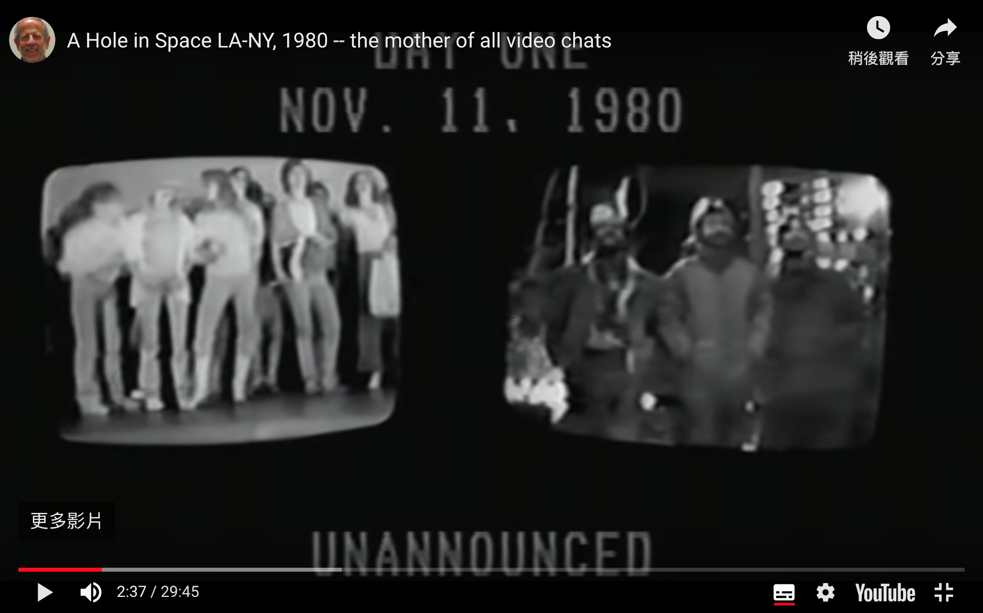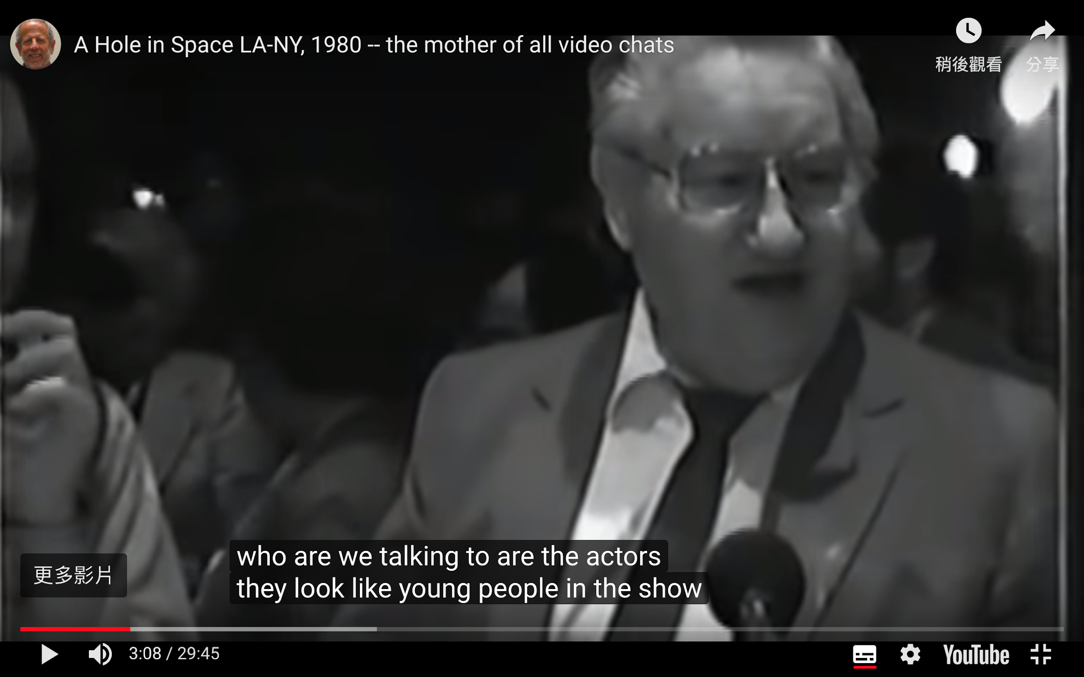

**Left to right:** Side-by-side display of crowds gathering in front of the installation at Culver City, LA and Lincoln Center, New York; Man wonders if the people on the videochat are hired actors in a pre-recorded video meant to convince them the feed is live (Press 2013).

### Multi-dimensional experiences from more than 2 perspectives

Hole-In-Space is an early multi-dimensional experience that surprised viewers with just two perspectives. More recent experiences further this capability, generating experiences from many more perspectives. CNN and Microsoft Photosynth, for example, recreated the 44th presidential inauguration from viewers’ inaugural photos, allowing interactors to relive the moment from any vantage point (Ostrow 2009). Virtual Reality and other Mixed Reality experiences are currently a popular medium effective for these purposes due to its heightened ability to elicit awe by heightening “presence” (Chirico et al. 2016).

### Creating embodied experiences using multi-dimensional data

In *The Message of Music,* Christian Moeller characteristically used data captured from different spatial locations during a live musical performance to create an embodied experience of multi-dimensional data. The final installation allows interactors to choose different locations to experience a playback of the performance, complete with “ghostly images of individual musicians... mirrored into the center of the installation space”, which “fade in and out of view according to listener’s remixing of the score” (Moeller 1996).

## Signature Moments in Data

The art of designing data visualizations from visual metaphors which generate visual signatures, or data points mapped to a custom visual code, have proven beautiful, stunning and powerful for affect-focused datasets such as art, music and history. The selected examples highlight classic examples of this data visualization method, as well as those especially relevant to this project.

### Giorgia Lupi

**The Lives of 10 Famous Painters**

Giorgia Lupi designed a well-known infographic for print publication that visually interprets the history of selected famous artists constructed by mapping their biographical data to custom designed icons. This visual metaphor uses a chronometrical timeline from left to right (birth to death).

Simple shapes and elements use form and color to code events sequentially along the artists’ timeline, such as taking a lover, having sons or daughters, travelling, and artistic production.

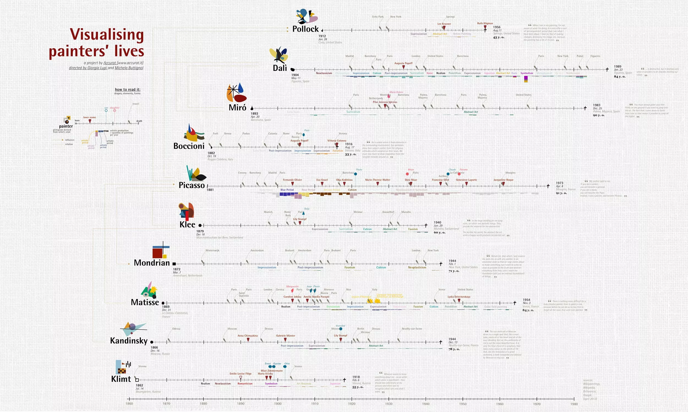



**Bruises — The Data We Don’t See**

A unique visualization designed using visual metaphor for a time-bound dataset that does not conform with the traditional “horizontal mental timeline” but still mappable to two-dimensional space is *Bruises* by Giorgia Lupi and team.

It chronicles the health and psychological condition of Kaki’s four month journey with a medical condition. The dataset used were days where Kaki’s platelet counts were measured, accompanied by the intensity of bruises and petechiae on her skin and Kaki’s level of positivity, cheerfulness.

The visual metaphor used were petals, and characteristics of that day were mapped to elements such as arrangement, color and texture. For example, the number of platelets were mapped to red dots reminiscent of pollen dusted on each petal. The distance between petals represents the time between platelet count days, the intensity of a bruise texture on the petals represented the extremity of Kaki’s bruises that day, and the presence of a yellow glow represented the extent of cheerfulness that day.

Notably, while the petals are sorted in groups where the distance between petals represents the time between platelet count days, they are not arranged in any other linear fashion; whether left to right or top to bottom. They are arranged as perhaps what they are in Kaki’s memory: a collection of memories in clusters.

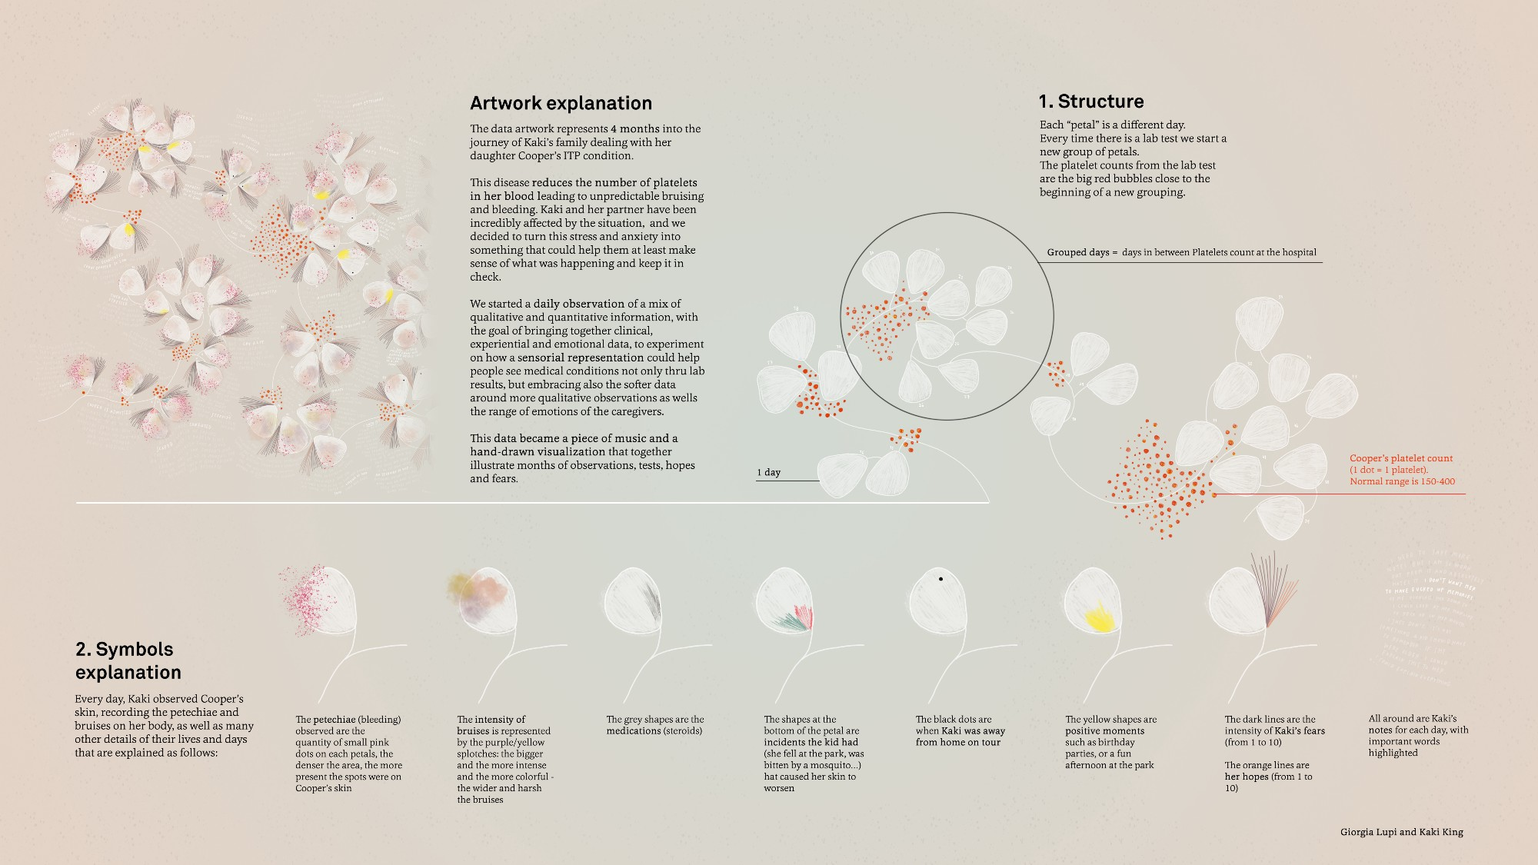

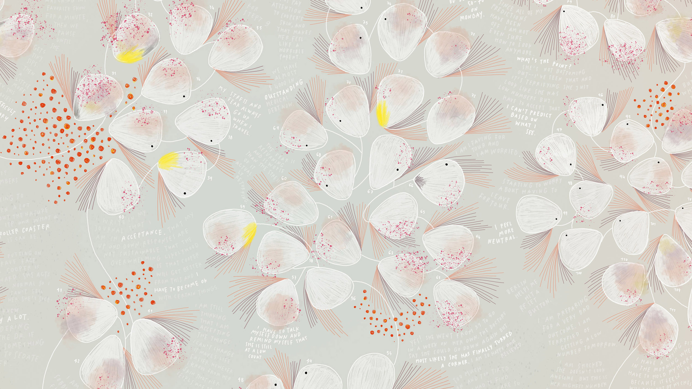

### Valentina D'EFilippo

Valentina D’EFilippo is a developer/designer that brings designing custom data signatures to represent characteristics of affect-riddled data to life in interactive web applications.

**Poppy Field**

Her project, Poppy Field, visualizes wars in history as poppies to invoke the tradition of using poppies as a commemoration of war due after World War I. The design is simple and powerful: the stem spans the years which it occurred, the size of the poppy represents number of deaths, and the petals on the poppies represent which continents were part of that war.

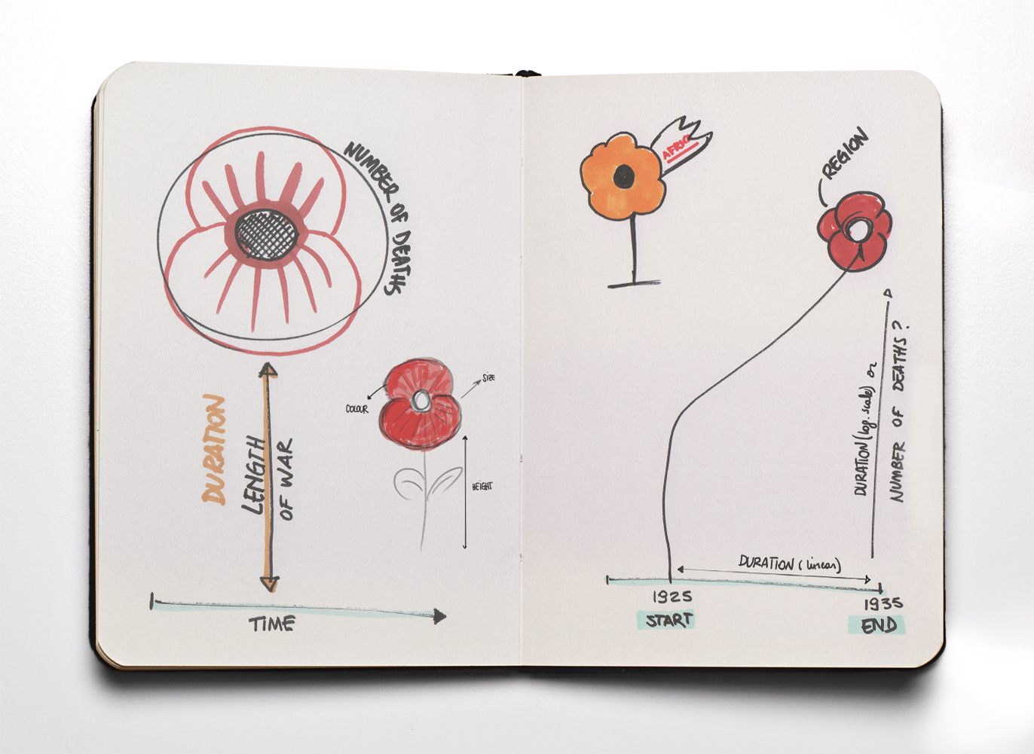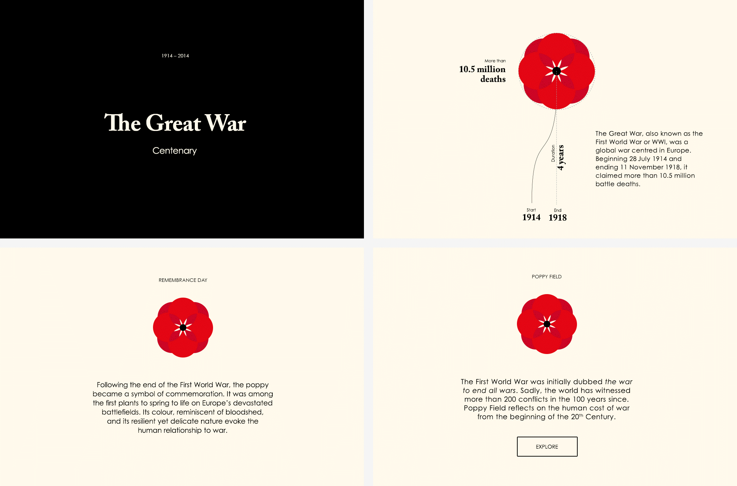

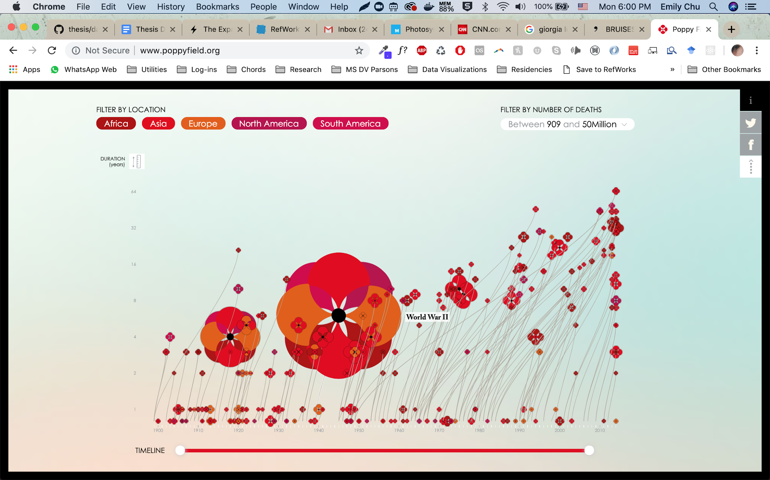

#### Histography.io by Matan Stauber

This data visualization by Matan Stauber takes a curated set of events from Wikipedia and visualizes them as points within the walls of a time tunnel spiraling from the outside in (Stauber 2015).

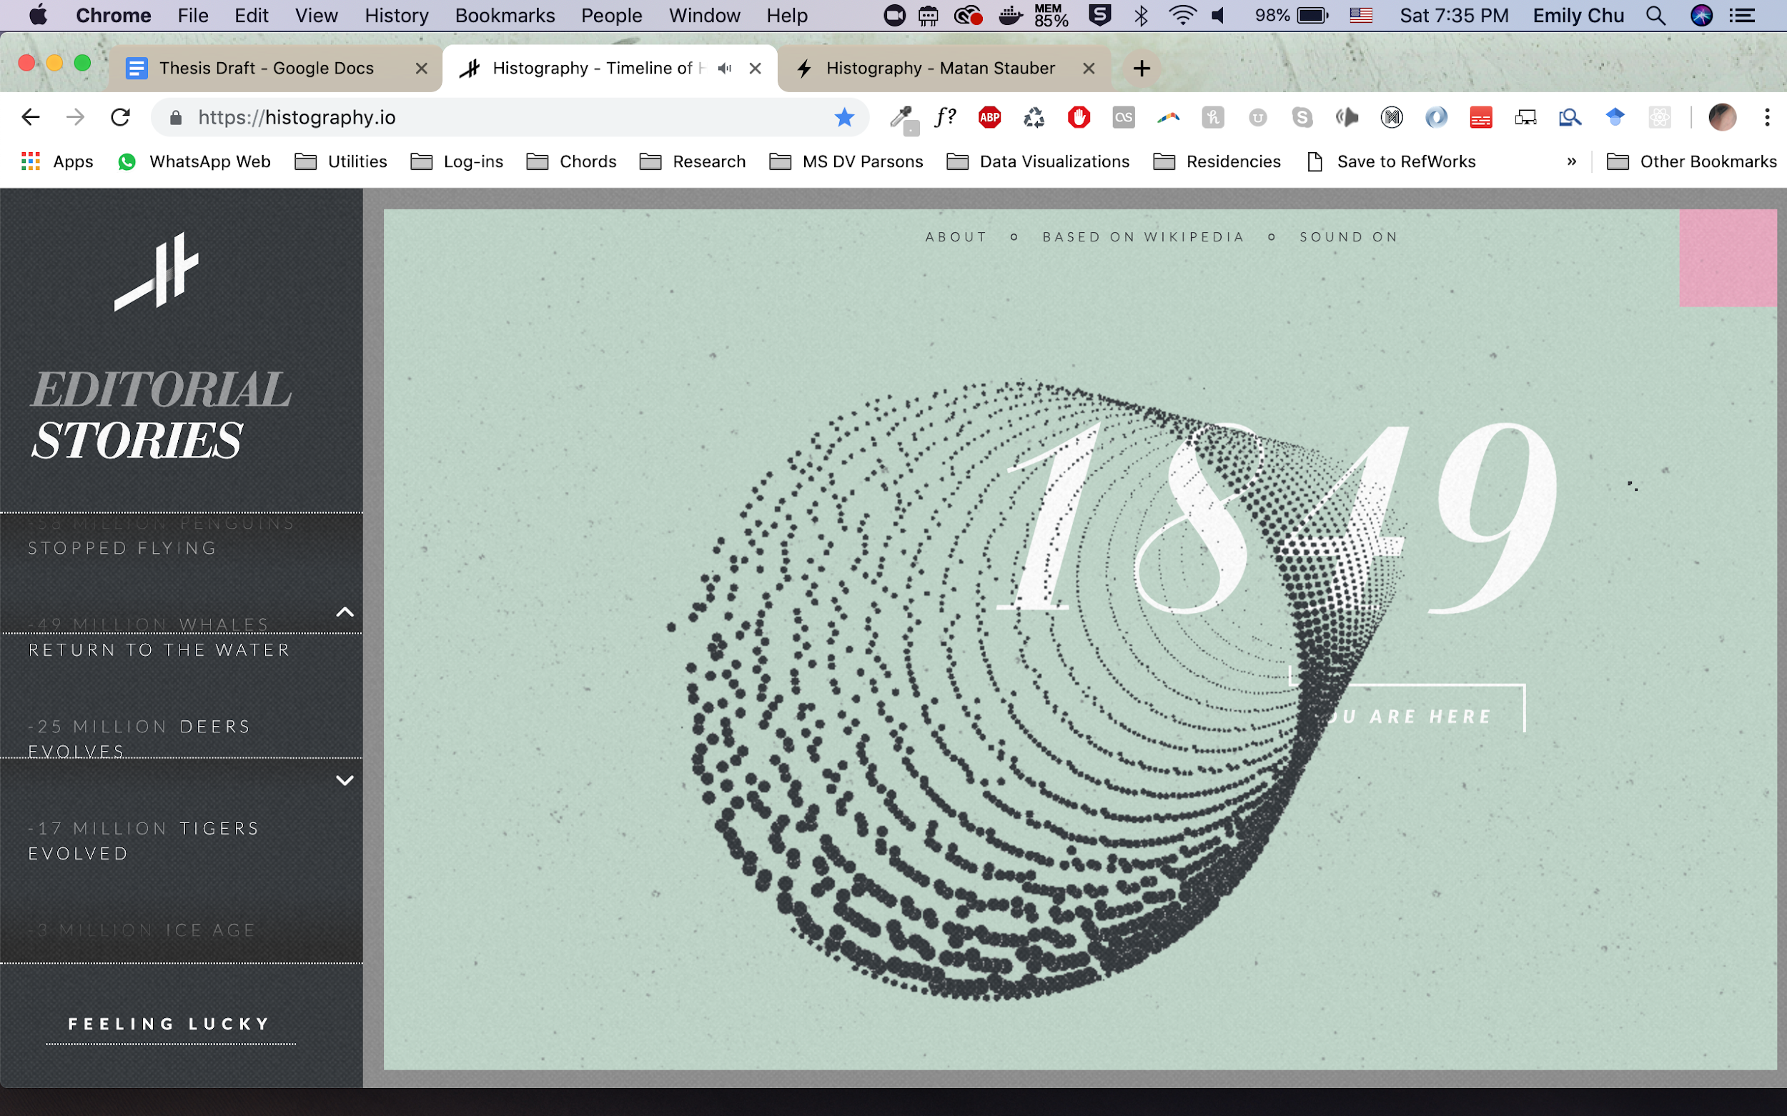

Based on the view selected, datapoints flow fluidly between the tunnel and chronometrical timeline means of structuring or embodying the datapoints. This design choice offers up the view of time as an organizing structure, and data located within time not as permanent localities but as placements of reference based on the preferred representation of time.

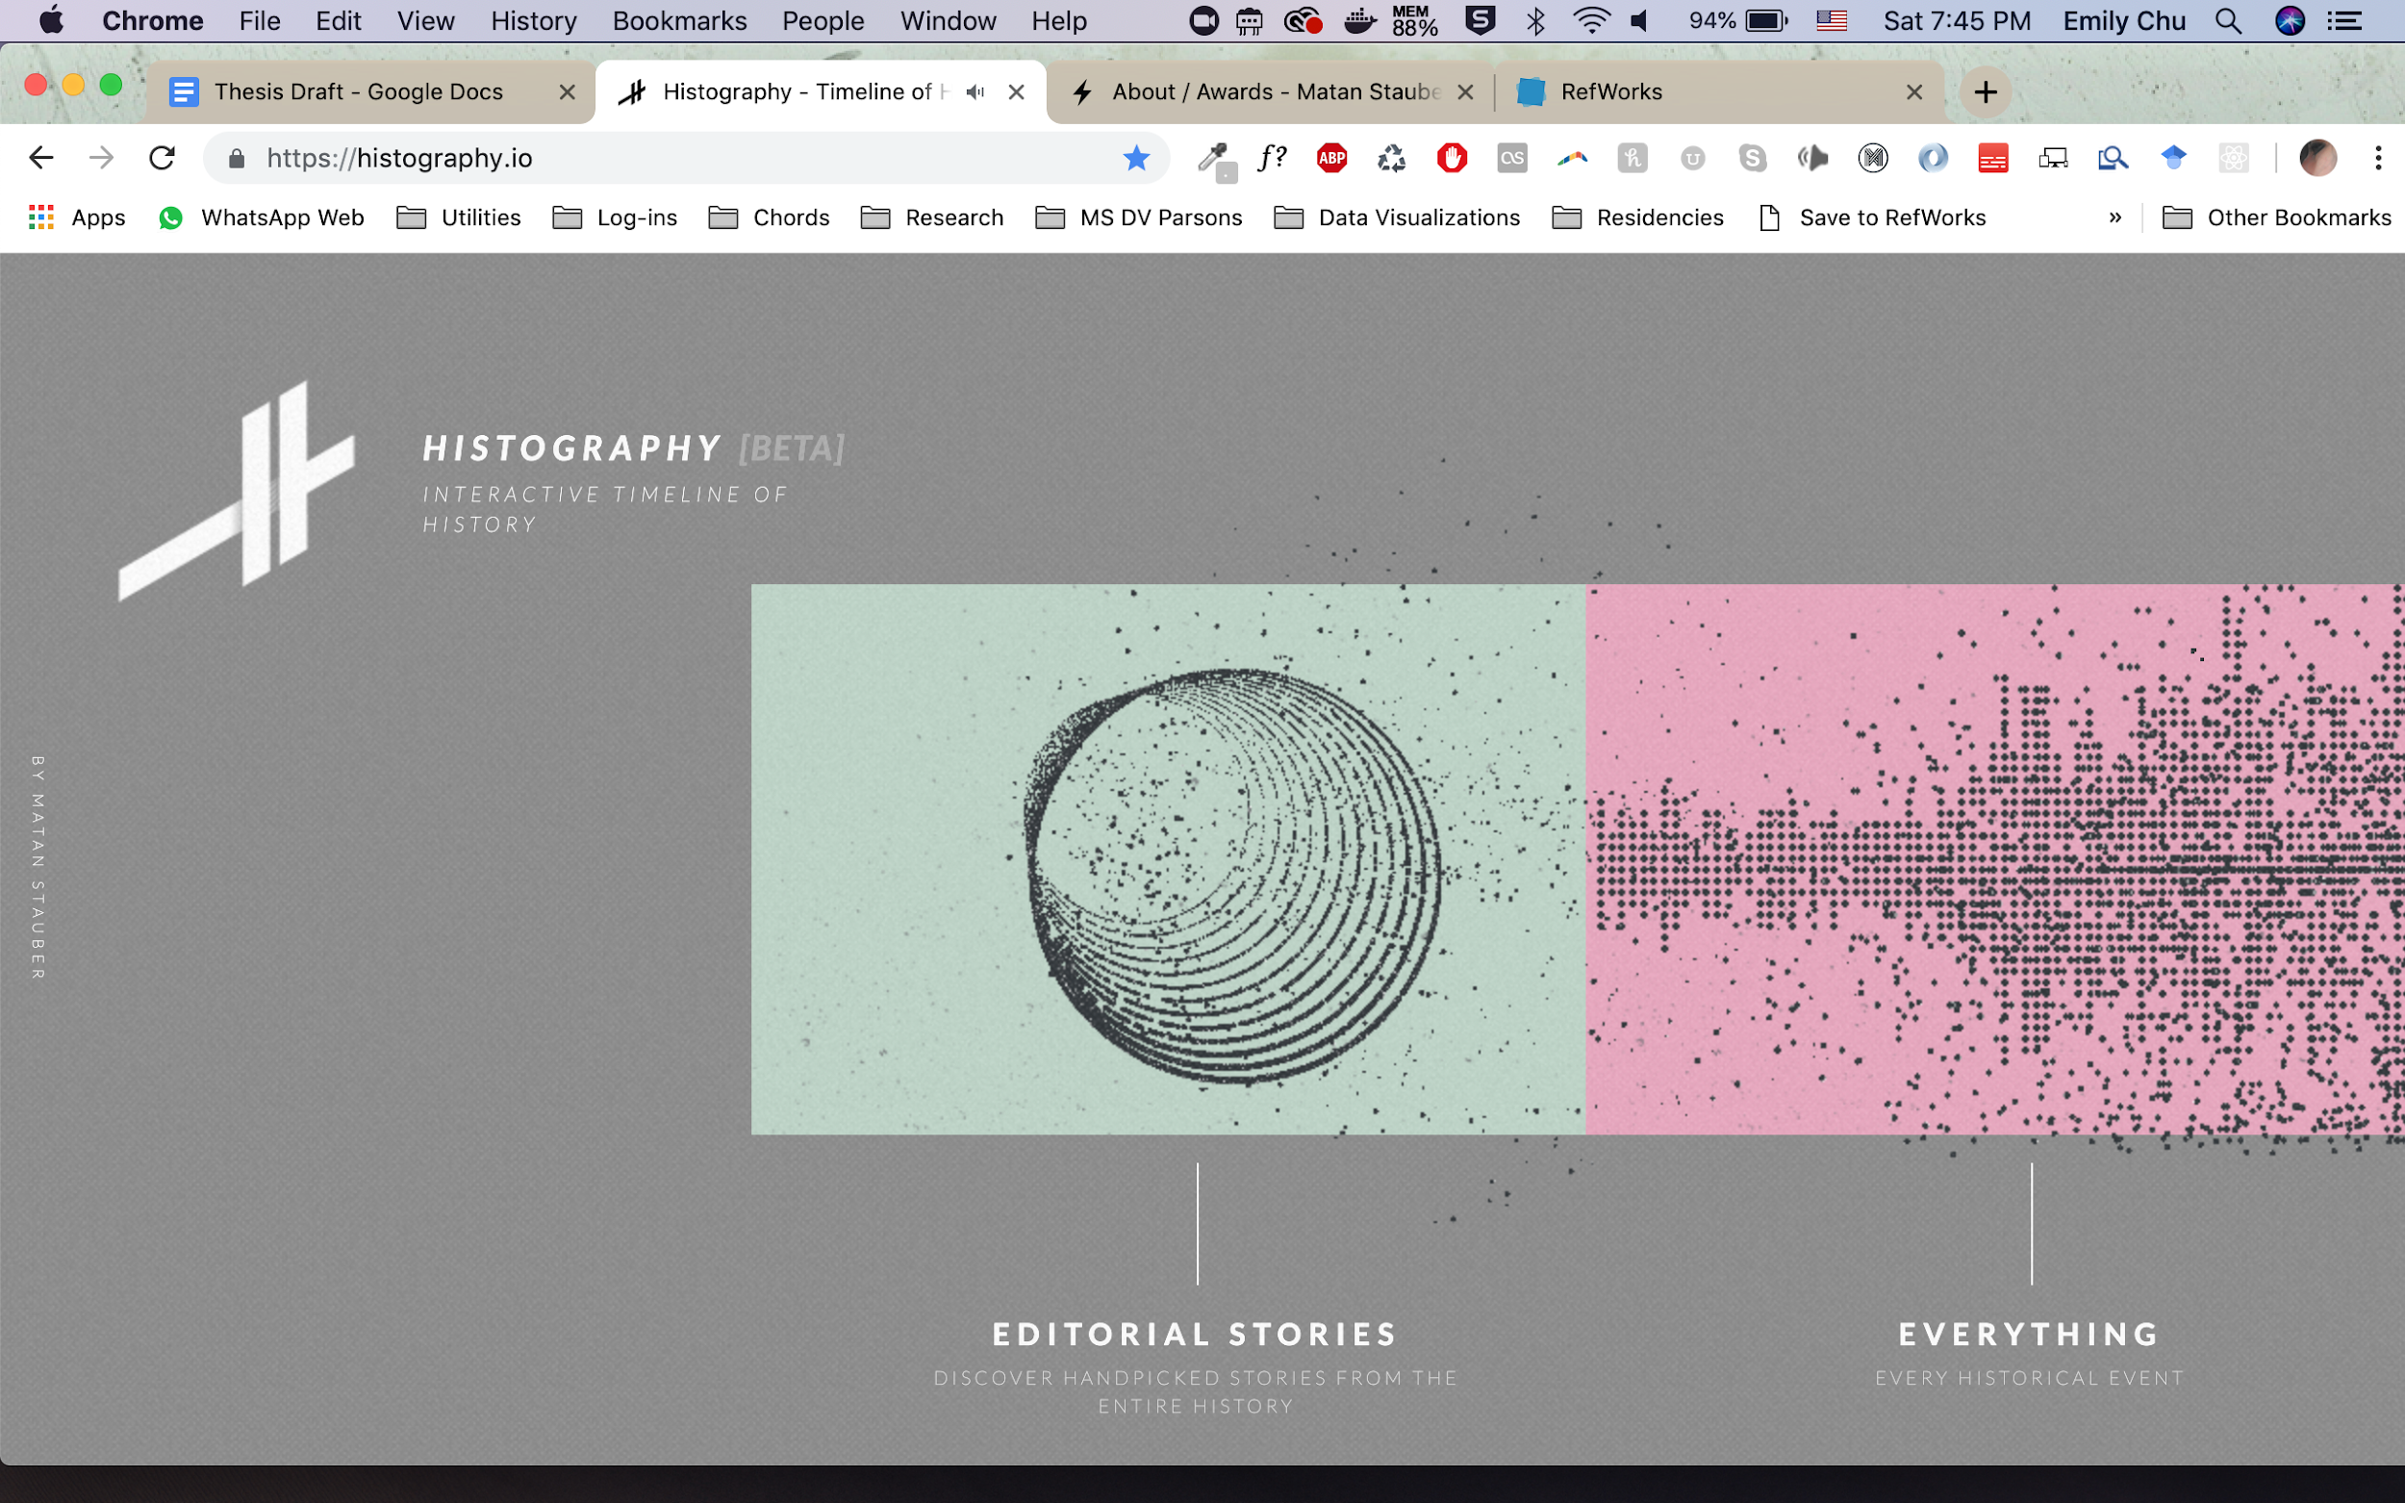

The interactivity of the visualization allows you to drill down into the metadata tied to each data point, such as image, wikipedia article text, link to any supporting media such as videos:



The “raw” event data points can also be organized in a chronometrical timeline view, following the familiar mental timeline flowing from left to right.

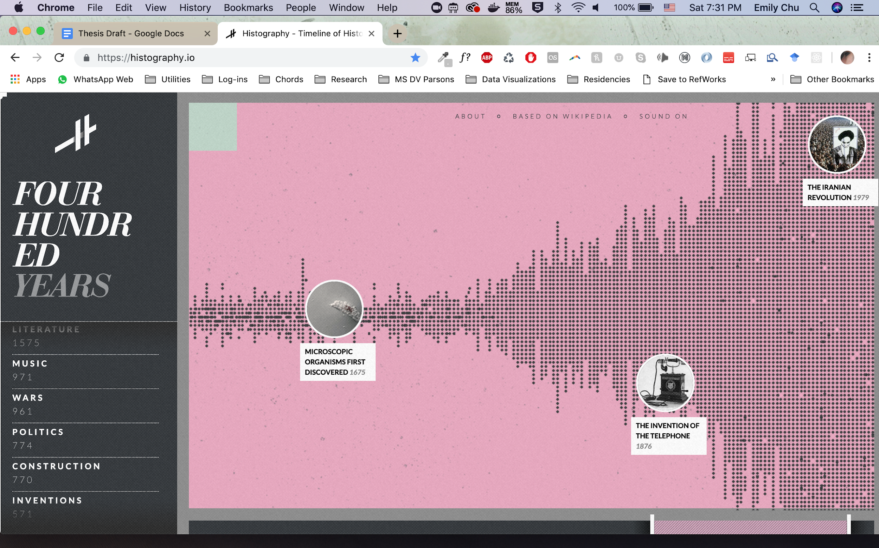

#### 50 Years Swiss Music Charts by D|One

In this data visualization by D|One, songs that topped the swiss music charts were organized into a universe experienced from 1968, which starts on the the outskirts to 2018, placed in the center (D|One ). To experience how the most popular songs progressed over time, the viewer is immersed in a three dimensional space where they both visually traverse into the present while their environment (constellations and audio representative of the most popular song in the moment in time) plays.

**Interactor scrolls into the center of the universe to traverse musical charts**

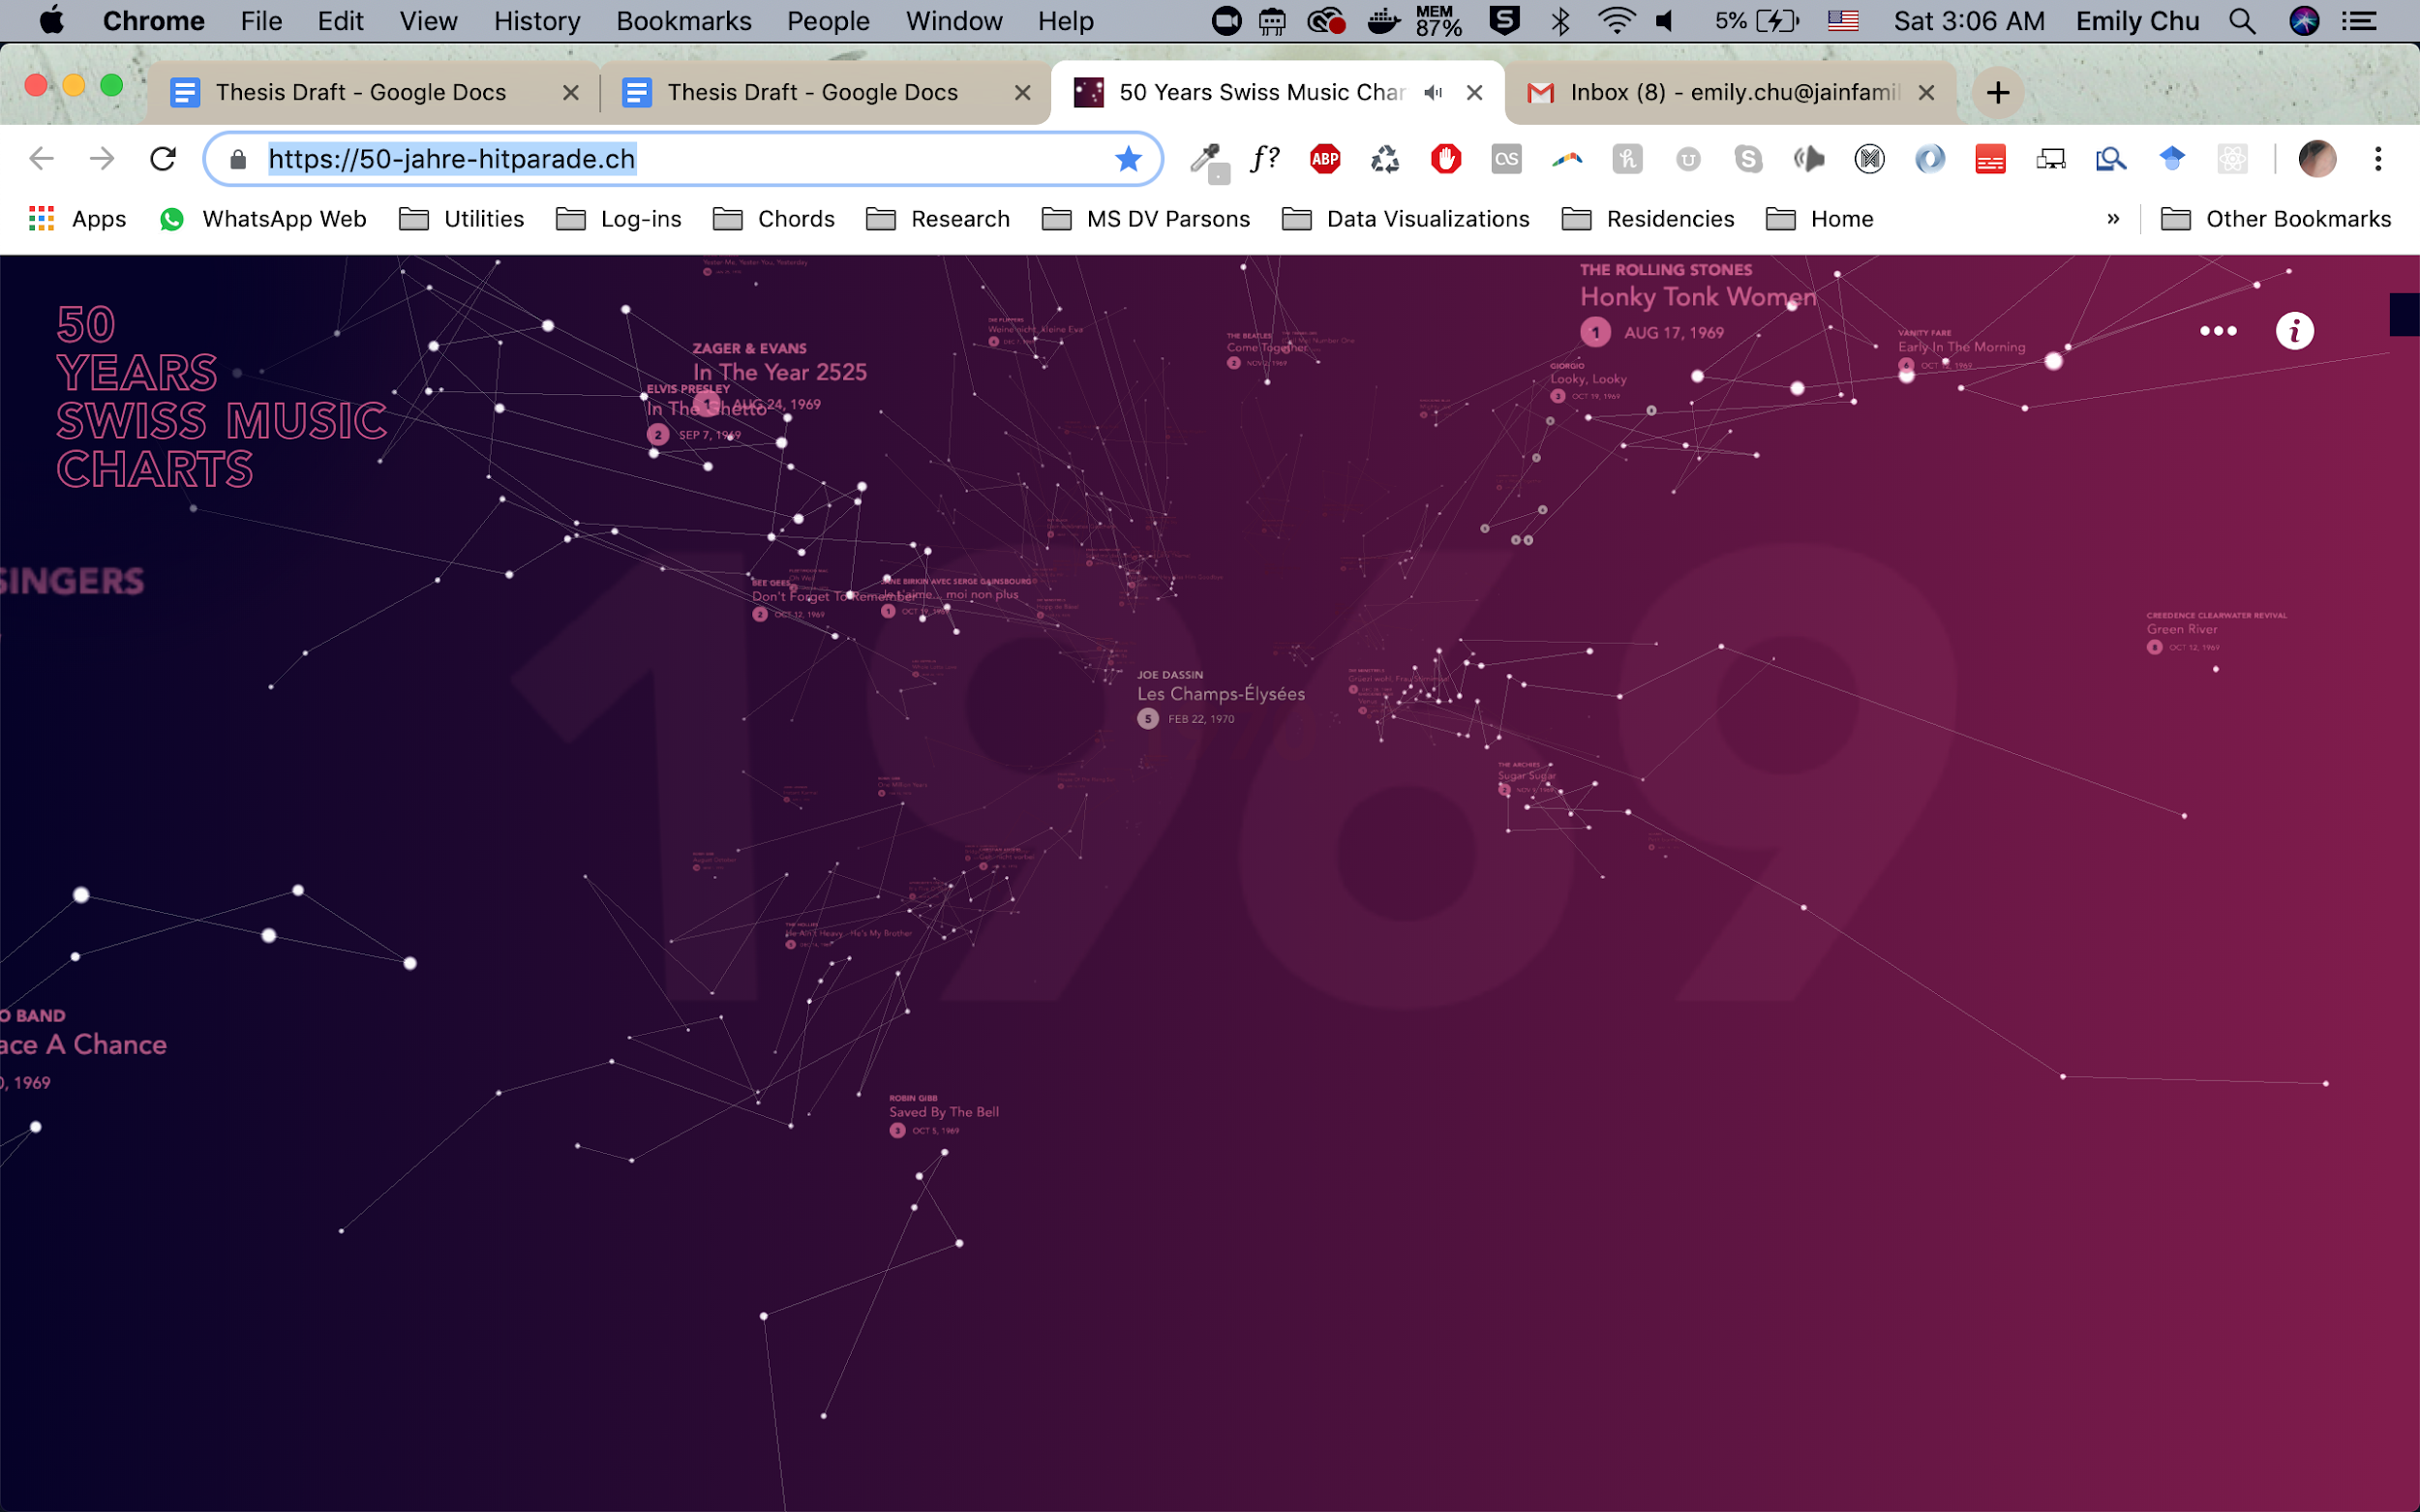

**How data-points of songs are mapped to signature constellations**

As the outside to inside time-space continuum embodies the experience of moving through time consistently throughout the experience, unique constellations are mapped from the placement and numbers of rankings for each song that topped the charts. The larger the constellation, the more times that song topped the music chart. The size and position of each star in the constellation represents its ranking; how horizontal it is represents the song’s mood.

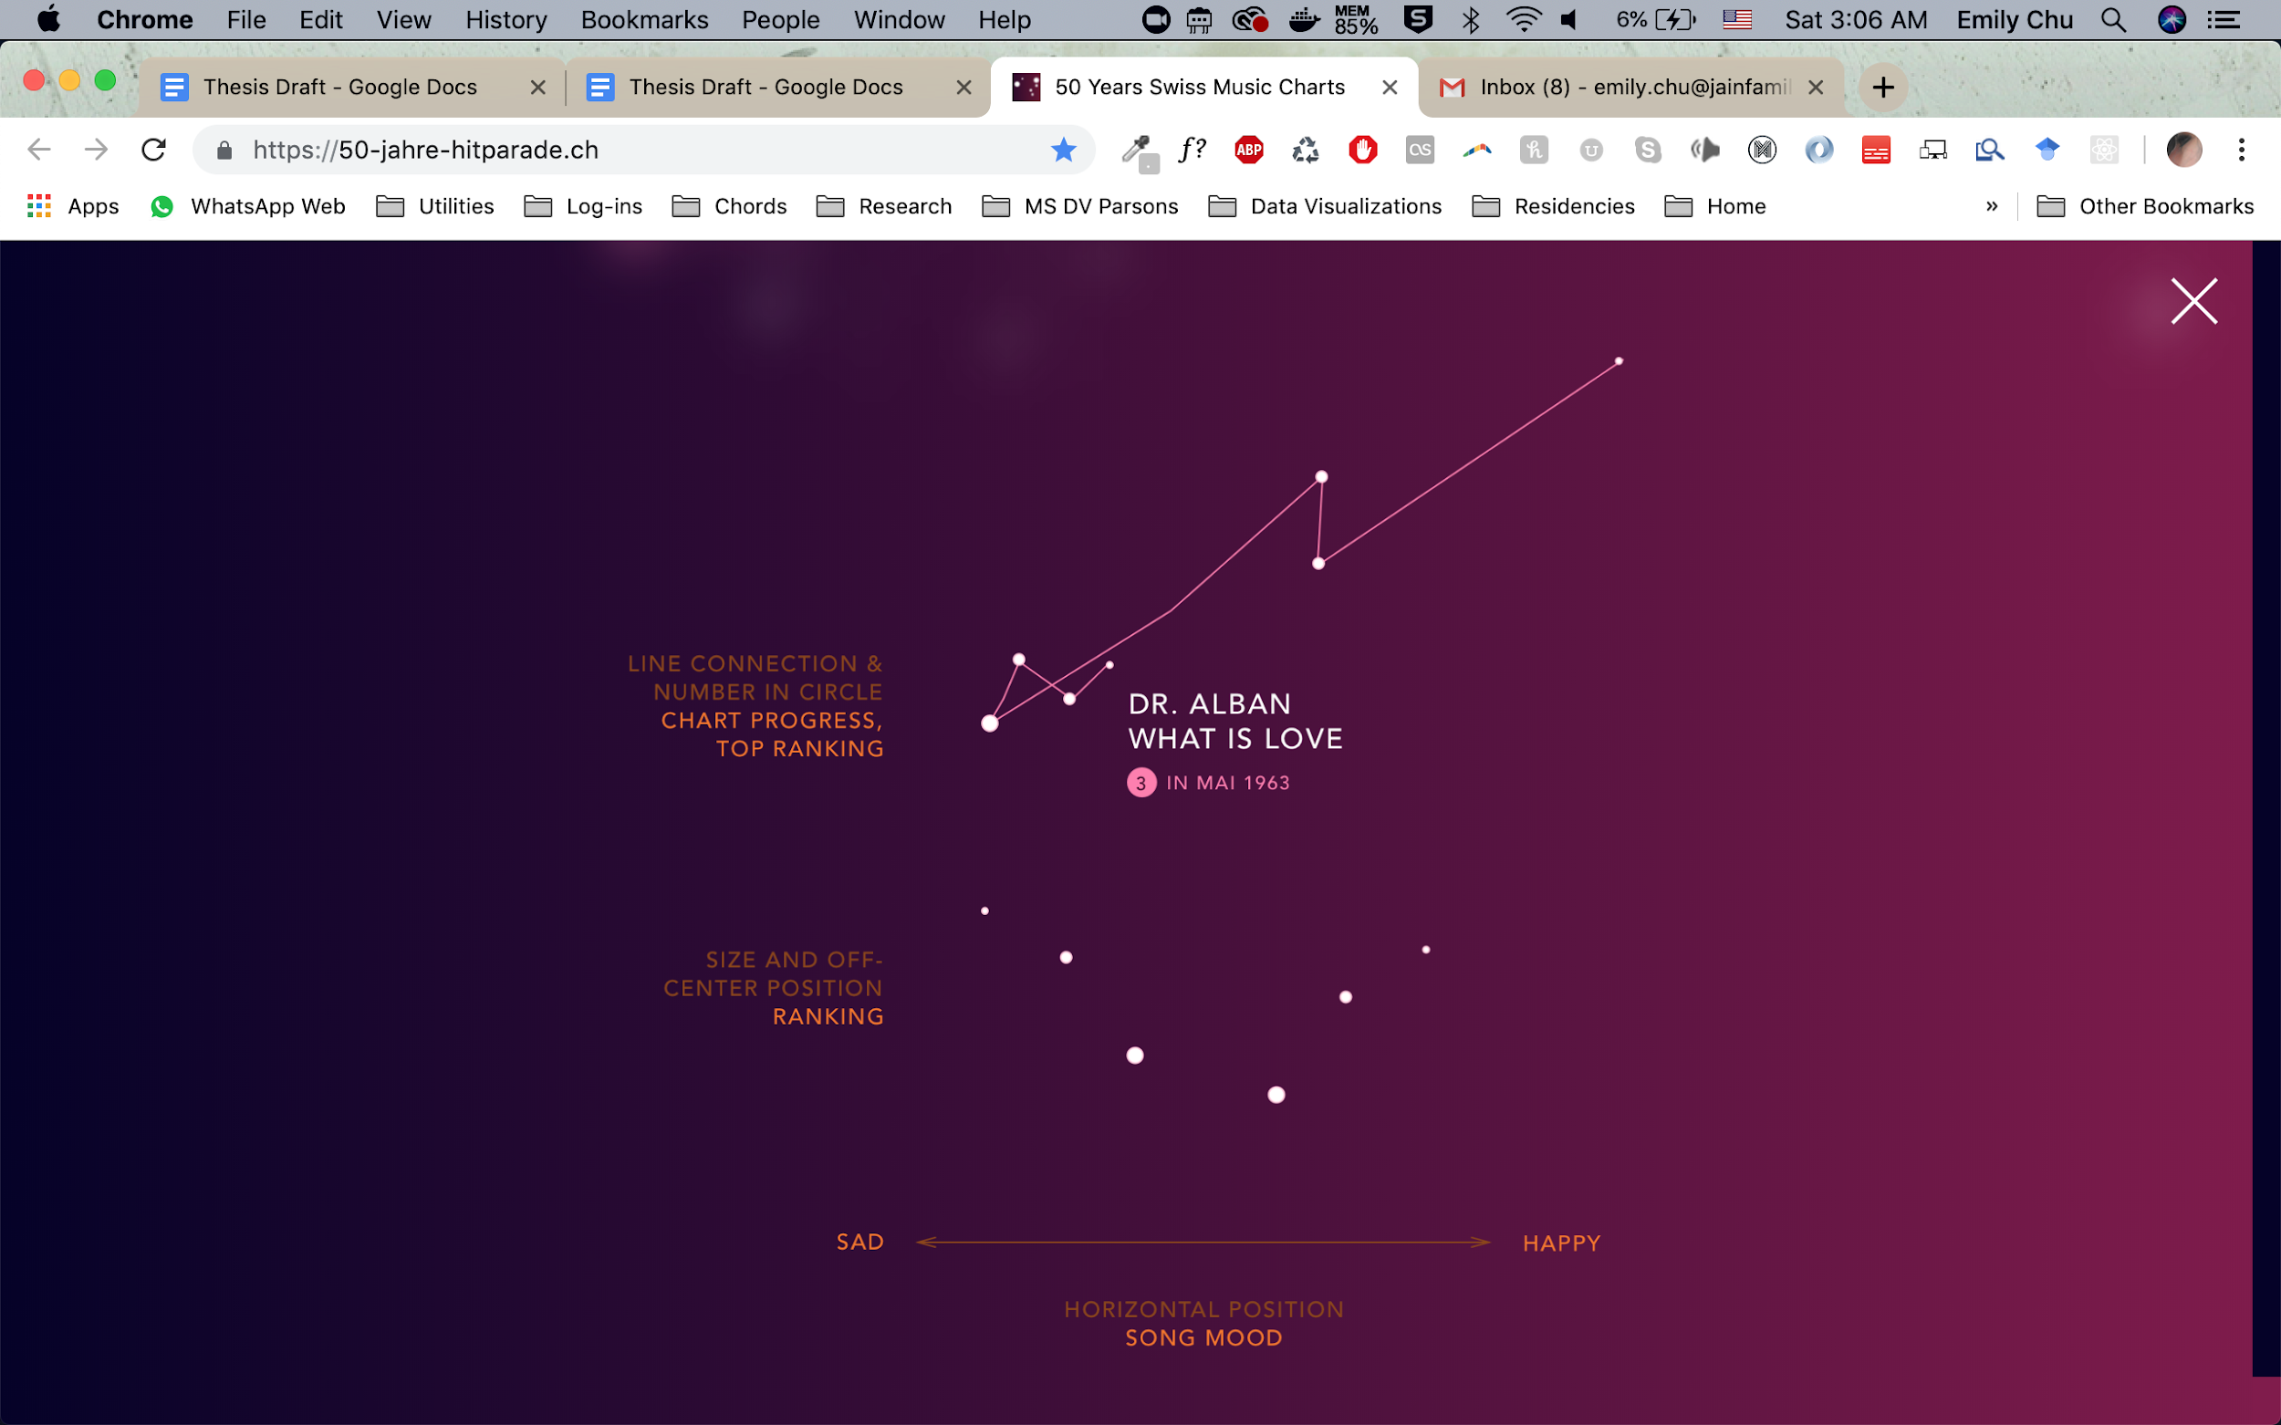

#### Reimagine the Game by the Economist

Reimagine the Game is a data visualization by the Economist that allows the interactor to play back any moment in the match and view the stadium’s reactions reconstructed spatially alongside audio playback of each moment in the match (The Economist ).

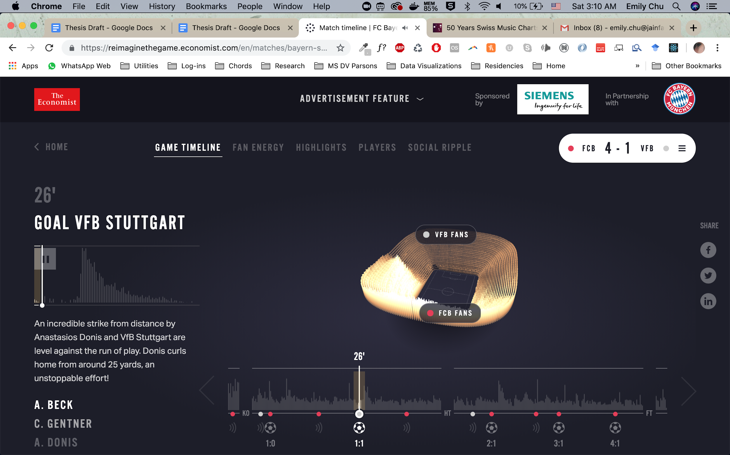

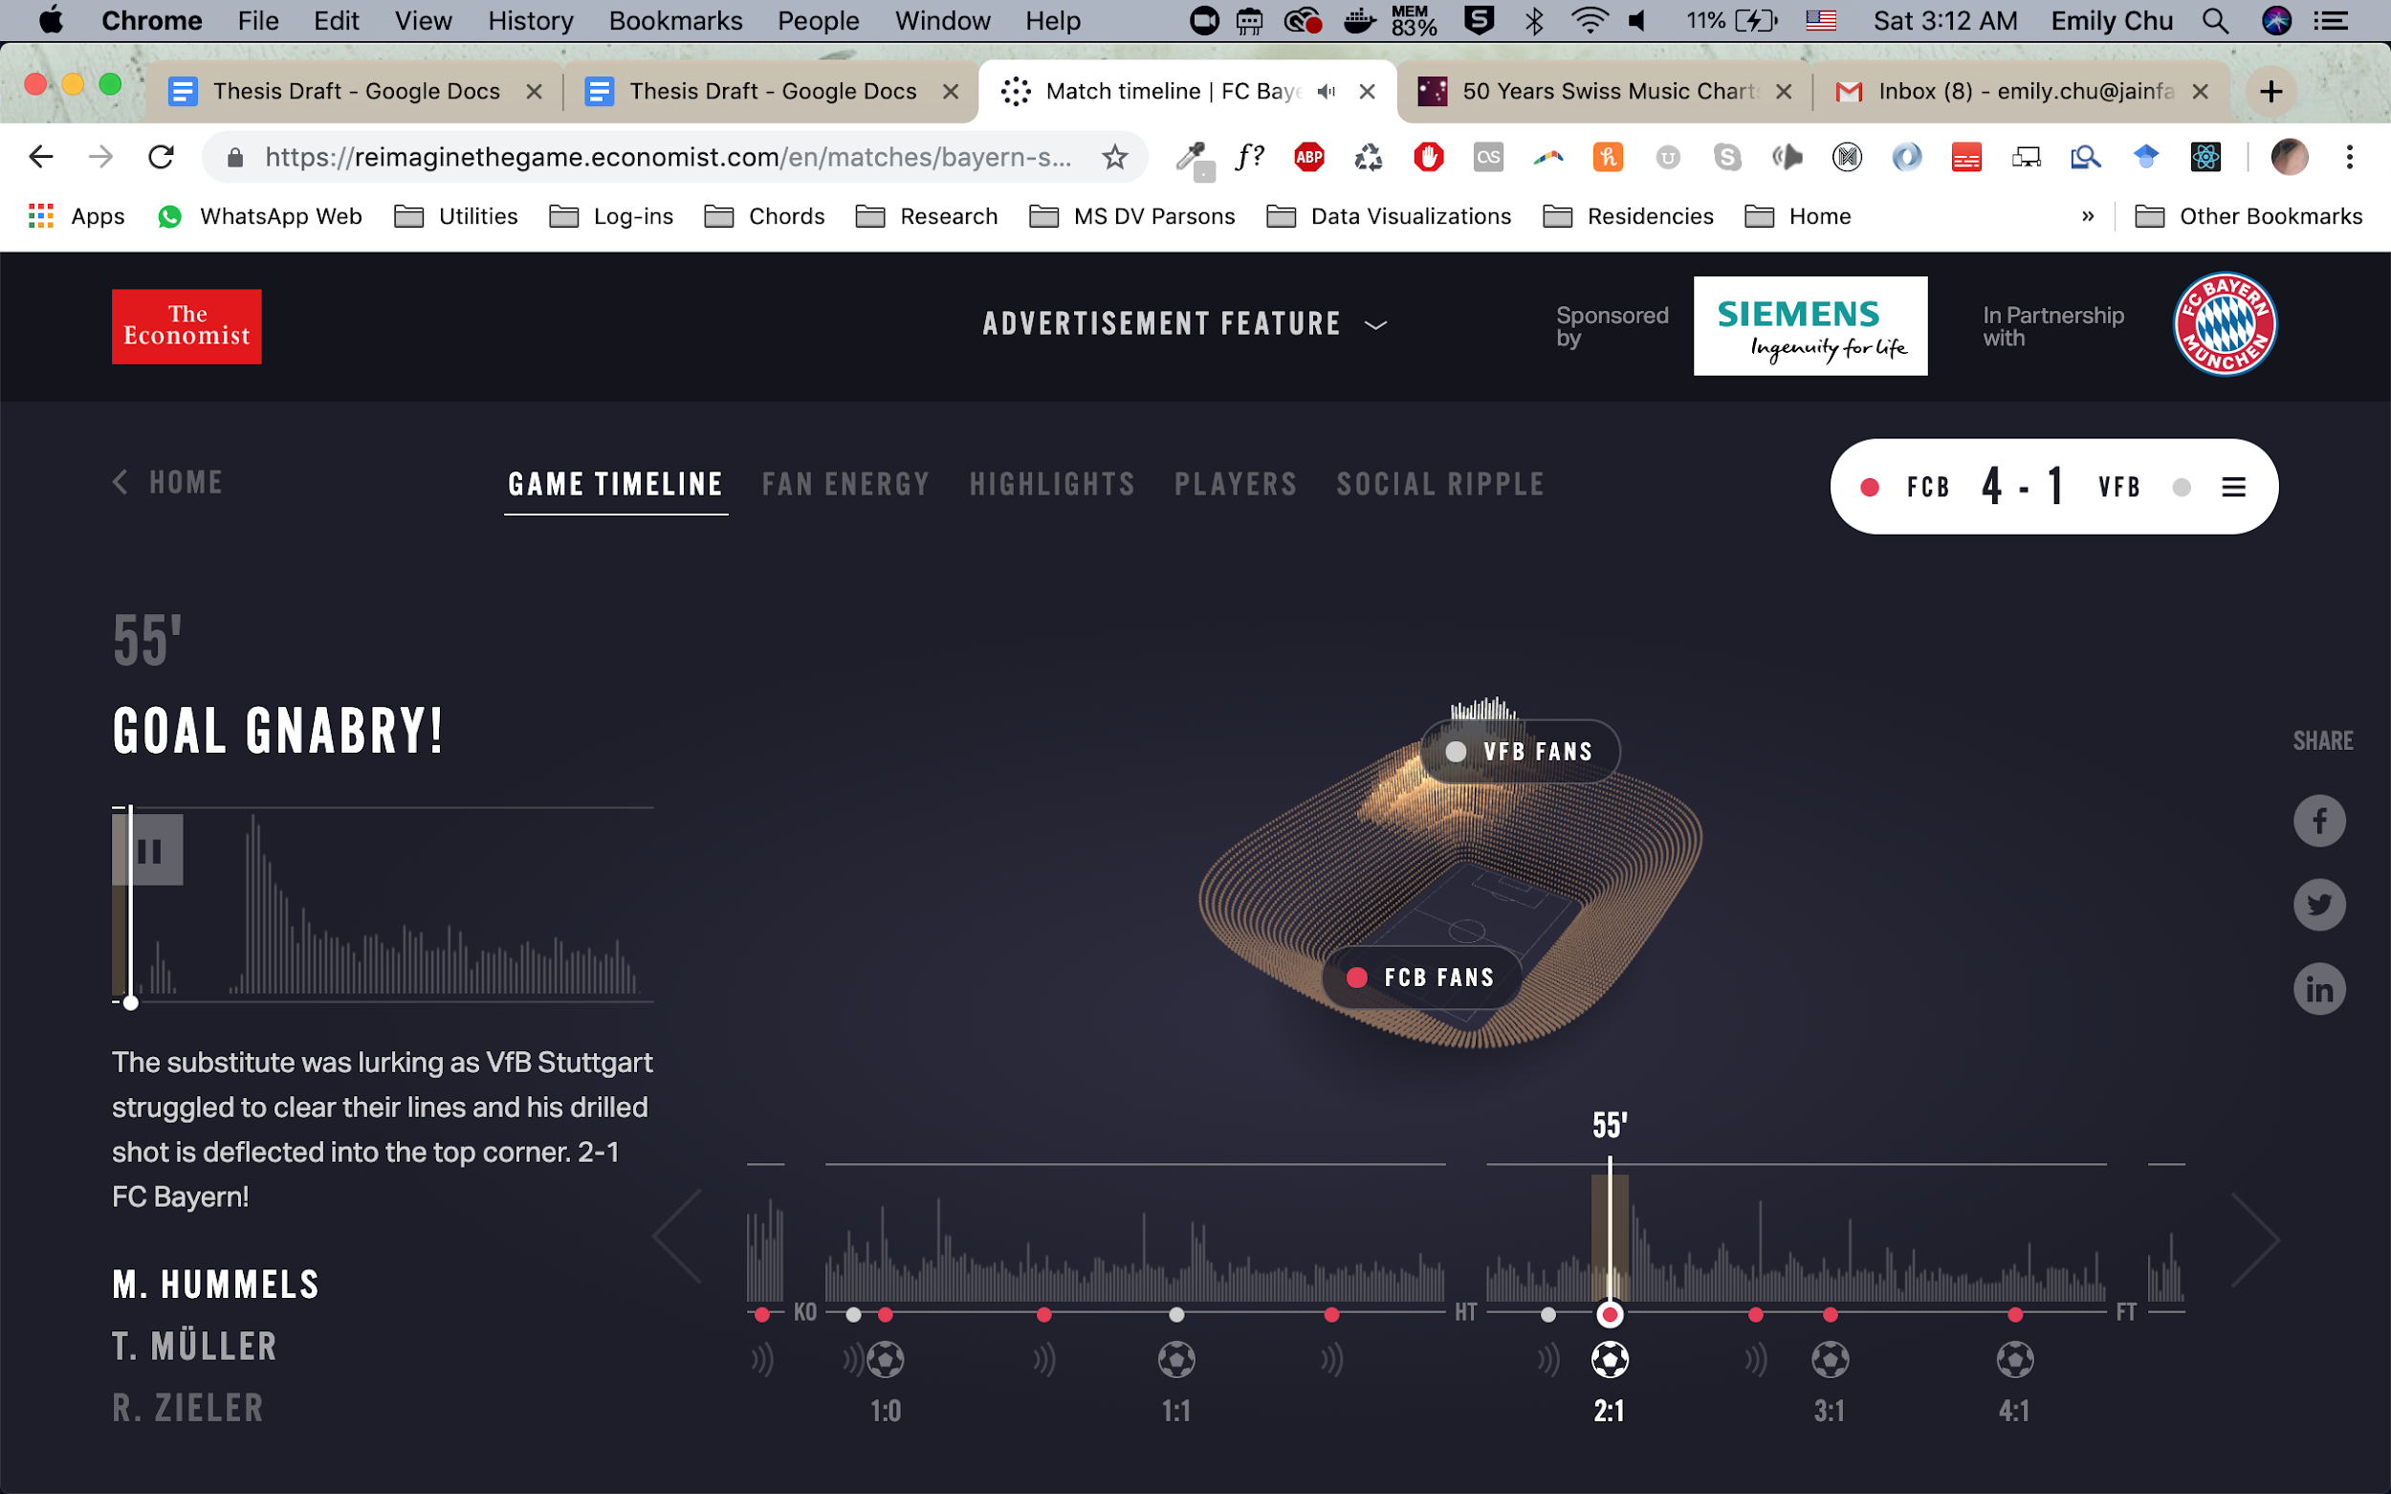

#### One Angry Bird by Periscopic

One Angry Bird by Periscope designed data visualizations coded by emotion and sentiment from the president’s expressions to generate unique feathers for each presidential inaugural address. It is important to note that each strand is mapped to a unique moment in the presidential address; feathers above the barb signify positive emotions and feathers below the barb signify negative emotions.

**How Feather Signatures were Mapped to Sentiment Data**

To generate visual signatures of generally “weak, positive, surprised” facial expressions in the president of each inaugural address in contrast to “strong, fearful, angry” inaugural addresses, for example, the Periscopic team created a sentiment and color code to map data to continuous (emotional strength), ordinal (positive, neutral or negative sentiments; primary and secondary emotions) and categorical data (happiness, fear/disgust/contempt, sadness, anger, surprise expressions).

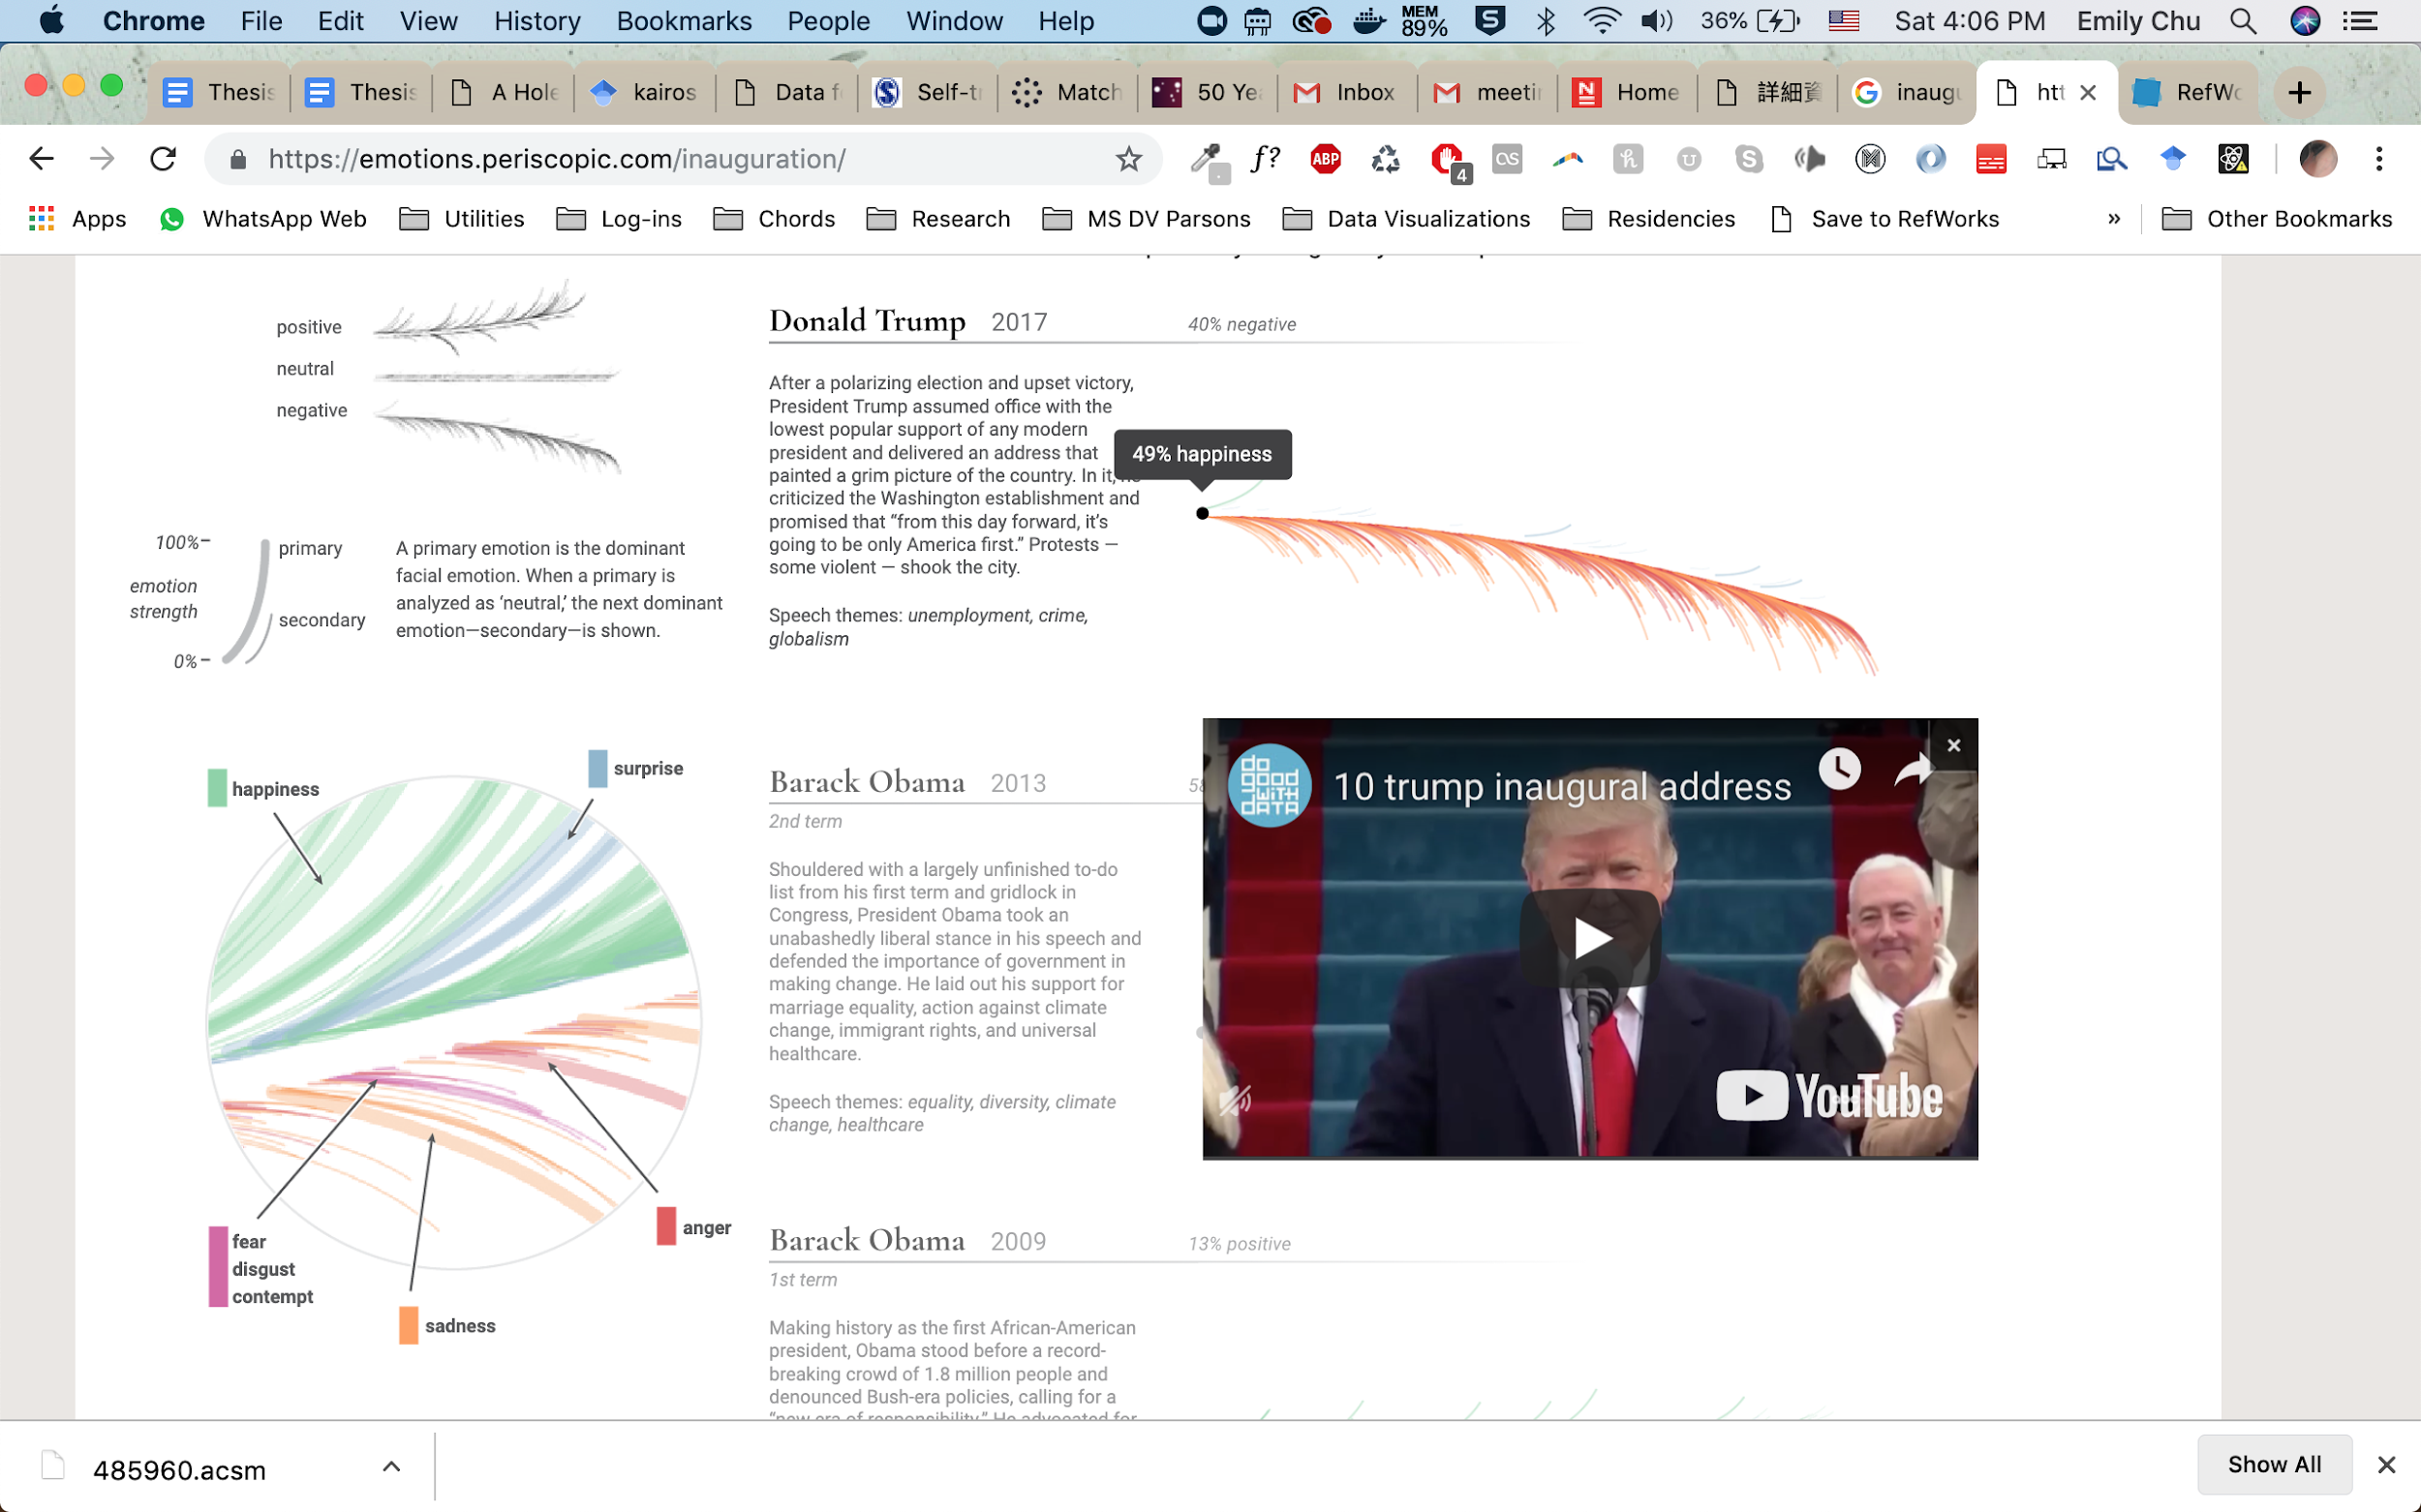

**Resulting Feather Signatures by Presidential Inaugural Address**

For each presidential inaugural address from 2005-2017, the resulting signatures can be seen in the small multiple view below. This set of data visualizations are a characteristic example of visual snapshots that offer viewers minimum effort to understand the major differences in datasets composed of individual moments but bounded within a single event.



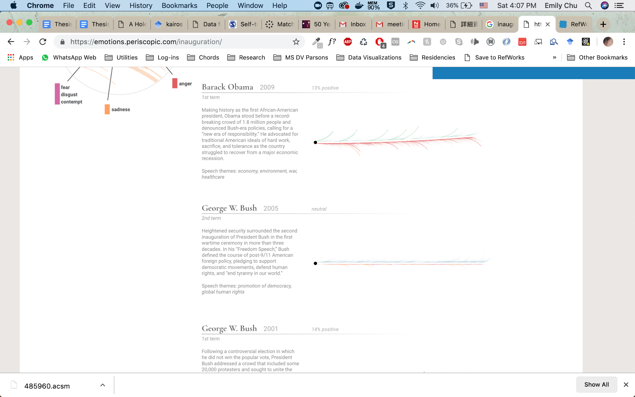

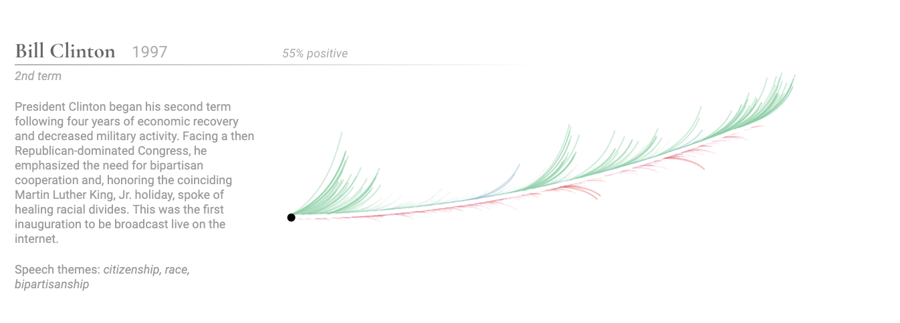

## 

## **V. Design & Development Process**

### Prototyping

**Wireframe**

To embody the participant in the digital recollection of the event, three views or states for data visualization are proposed following the elements of embodied time chosen for experimentation in this project:

1. Situatedness
2. Activity
3. Perception

The participant should be allowed to toggle back and forth between all three states at any moment in time, thereby navigating different digital spaces throughout the performance.

The wireframe below demonstrates identification of these essential components for the visualization and inform a pathway for the ground build.

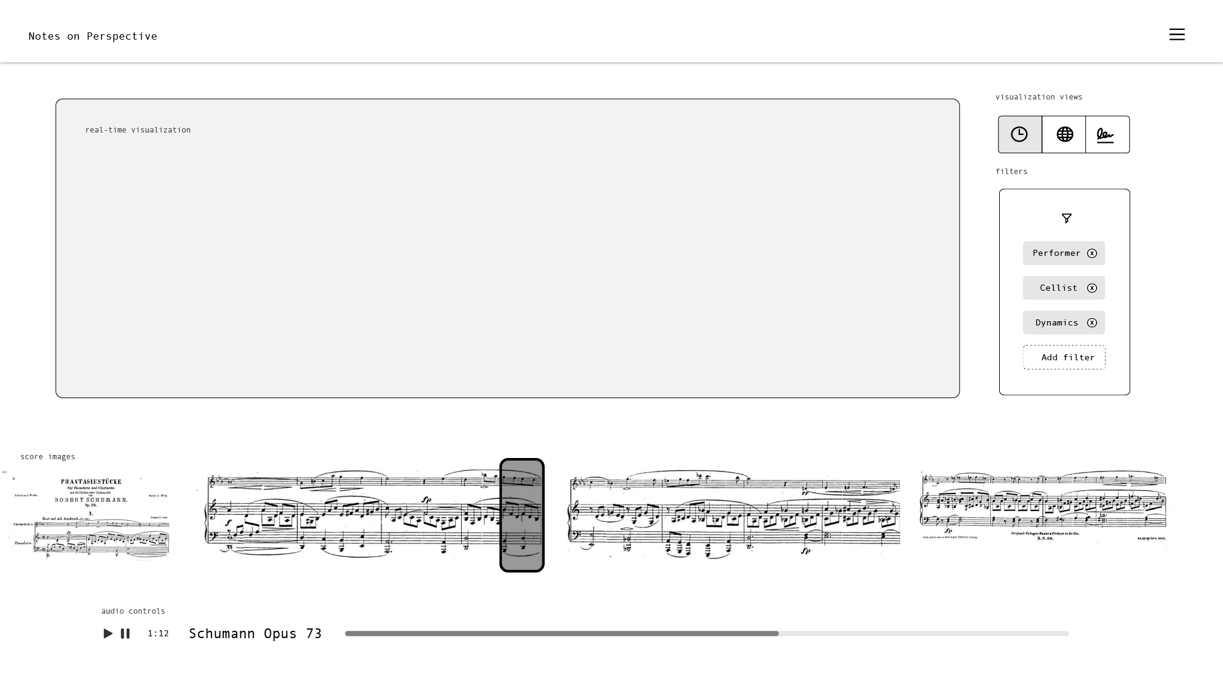

#### Description of essential components

1. *Score image progression*

As the sound recording of the performance progresses, participants should be able to follow along with the score at each point in time, as the recital critique of Fantasiestucke is focused on how musicians are interpreting the music from this source of truth. In essence, it is the major point of study of the original event which should be highlighted at every moment.

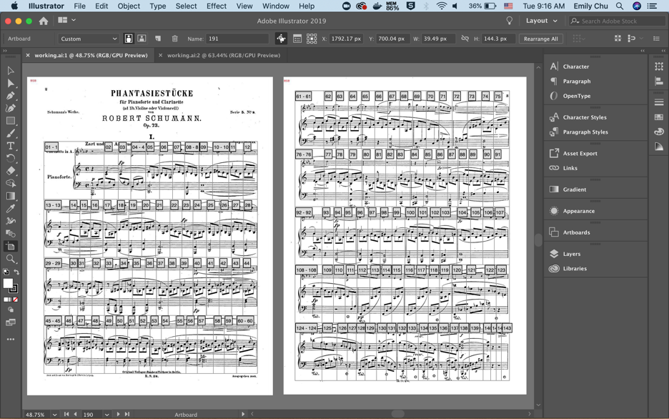

To accomplish this, the score was cut up into individual images by beat. All images shared identical original height dimensions to allow for easier responsive design.

*2. Filters*

One of the affordances of preserving events as a digital artifact and reconstructing data captured from it is that multidimensional perspectives can be included. We are freed from the first-hand experiences we are bound to as inhabitants of our bodies in physical space. These filters will serve the purpose of allowing the participant to play the event at any moment from any of the attendees’ point of view:

* Performing artist by instrument
* Non-performing artist by instrument
* Audience member by familiarity with the piece

*3. Audio Controls*

The original performance recording acts as the default control for controlling the sequence of visualizations within the application. Participants are able to navigate to any part of the performance to retrieve data from that moment. They are able to pause it to better dive into all the information that is available across all views.

### Data Structure

The diagram below illustrates the design schema for the Notes on Perspective single-page application. The application runs dynamically on one page, with one overlay static page where information about the project can be dumped and editorialized. The single page application reads from three data sources on load:

*Data sources*

* **Profile data:** All collected data (.csv) demographic and musical experience profile of each attendee from the performance. The ‘role’ field can be used to match with the Reactions data to tie reactions to comprehensive information about who experienced that reaction
* **Reference data:** Data (.csv) that identifies the timestamp, score image name, and cluster analysis label for each moment of the performance by measure and beat (i.e. Measure 1, Beat 4).
* **Reaction data:** Provides all raw data (.json) collected from each moment of the performance tied to measure and beat (i.e. unedited comments); each moment is tagged by category.

*States*

* **Activity View:** The activity view provides a sense of all collected reaction activity that occurred throughout the performance, borrowing from understood social media design elements and nomenclatures. This view is meant to be an easy direct representation of the data that helps participants enter into the experimental visualization with ease and a sense of how to read all other views.
* **Situated View:** The situated view humanizes all attendees, the originators of the data, by presenting their role by type spatially along with biographical information to get to know who they were. This is an attempt to situate the participant among the semblance of other human bodies, who are not divorced from their data, but an integral part to the its meaning-making over the unfolding of the performance.
* **Perception View:** The perception view acknowledges that lived experience contains elements of intuition that remains unreplicable in digital experience. Some of these elements, however, are identified and explored in mediums in VR (virtual reality), XR (experienced reality), AR (augmented reality), and MR (mixed reality). Building off of research done in this field to generate a sense of presence and awe (Chirico et al. 2016), the perception view holds that the emotions generated in the environment at hand plays a vital role in forming insights and understanding of information regarding an event as it unfolds in front of us.

**Data Architecture**

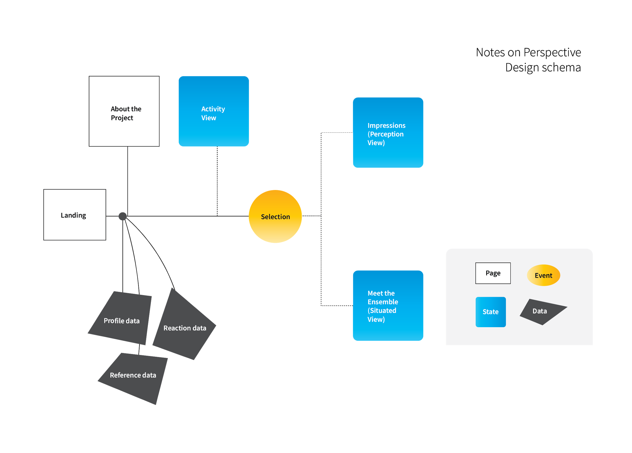

**Data Dictionary**

*Reaction Data*

The raw data was collected from a series of surveys identifiable by role in the musical performance. Each survey is identifiable by the role of the author. Data captured from each individual participant through these surveys can be understood in six parts:

1. **Profile:** Identifiable information for each participant denoted their role in the performance (Performer, Class Member or Back-up Performer), a unique identifier integer (i.e. 1, 2, 3), what instrument they play if any (piano or cello), and whether they have any familiarity with the piece (have listened to, have played, have performed).
2. **First Moment Reaction**: this is a written comment that can be tied to specific measure(s) of the musical performance selected by the participant. Researchers then coded these comments into sentiment (positive or negative), and a best-fit subject matter category (dynamics, tempo, balance, rhythmic motion, synchronization, communication, matching musical idea, expressivity, tone quality ending).
3. **Second Moment Reaction:** Contains the same information as the First Moment Reaction for a different moment of the performance selected by the author.
4. **Third Moment Reaction:** Contains the same information as the First and Second Moment Reaction for a different moment of the performance selected by the author.
5. **General Reaction:** this is a written comment that summarizes the overall impression of the performance by the author. It is not tied to any specific measure in the piece; it is a general characterization of their judgement. Researchers also coded this by sentiment (positive or negative), whether it was a reaction to the music, performance or both.
6. **Peer Review:** Two other participants who also witnessed the same musical performance reviewed the moment reactions and general reaction. These reviews are identifiable by reviewer role and familiarity with the music (have listened to before and/or have played before). Researchers then coded these reviews as agreements or disagreements (same or different).

*Musical Performance Data*

To be able to visualize this information tied to the musical performance, a dataset was generated which includes beat by beat information:

* The measure (i.e. 1 to 67)
* The beat (i.e. 1 to 4)
* Timestamp at which the beat occurs in the musical performance audio file (i.e. 1.12)
* Reference to local image of the score tied to that beat (i.e. 1.png)

*Minimum Grouping, Sorting and Filtering Requirements*

The data must satisfy the minimum grouping, sorting and filtering requirements:

* Unique identifiers for each moment and general characteristic reaction
* Ability to group by role (i.e. performer, audience, back-up performer)
* Ability to group by instrument (for all performers, back-up performers, and audience members who specified ability to play the piano or cello)
* Filtering by reactions occuring in any particular moment (i.e. a specific beat or set of beats) with corresponding audio and score visuals available
* Ability to tie sort reactions by most similar (sentiment and category)

### 

### User Experience

This section details the user experience design elements produced for each of the three states, research supporting design decisions where applicable, and how production was executed.

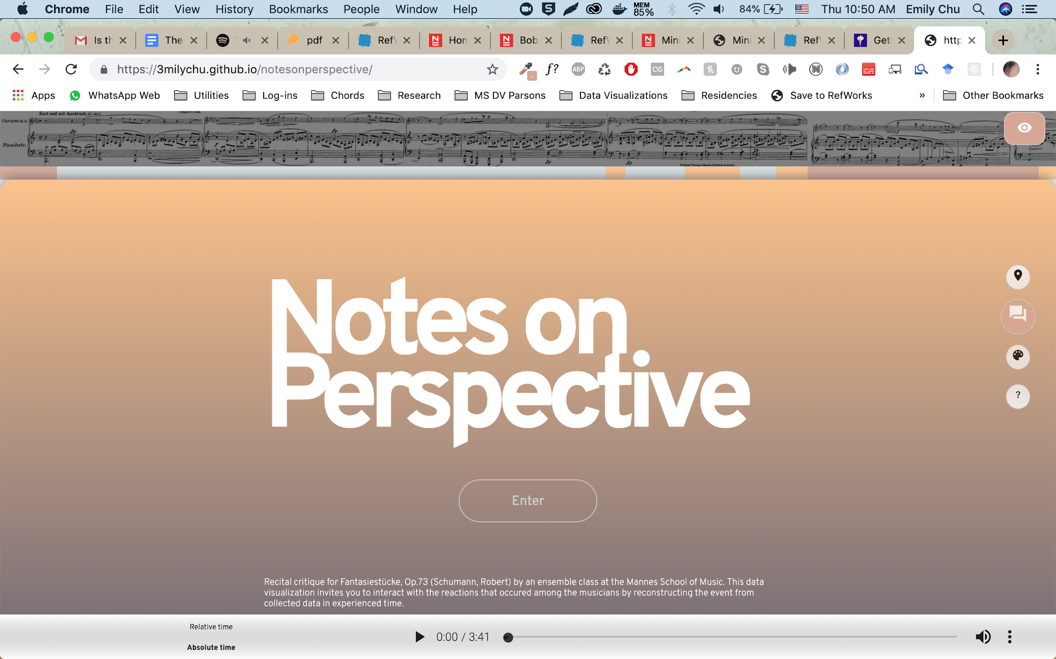

**Color Score**

*Design Element*

Each beat of the score was clustered by musical notation and sequential progression (timestamp, measure number, beat number). The effect is a computationally sorted view of the score by theme. Clustering was run using a k-means model for 5 clusters. The five clusters were named: Melody (salmon), Magic (salmon + green), Building (orange), Emerging (grey blue), and Drama (black + tan). This was done to help interactors quickly interpret reactions in the context of the musical content being critiqued. By giving interactors a visual gateway into how the piece moves into different musical movements, individuals may be better able to draw personal insights into how and when professional musicians are reacting as they do at certain moments of the performance.

*Design Research*

Poast defines color music as a “a complex representation of musical composition ideas in a visually fixed form” (Poast 2000, 215-221). In 1995, Wilmer proposed the idea of a “Rainbow Score” as an example of color encoding for musical scores, in which melody and chord progressions are translated into color combinations (Wilmer and Britto 1995, 129-136).

Visual music, color music, and visual scores can contribute to developing self-evident musical scores which are “truly reader-friendly” (Wilmer and Britto 1995, 129-136). Notes in Perspective builds upon this work by clustering the musical score by musical notation and sequence, then encoding the different themes by color.

*Execution*



function getScore() {

d3.csv('data/cluster_results.csv')

.then(function(data) {

for(i=1;i<274;i++){

target=document.querySelector('#page1');

height=window.innerHeight

div = document.createElement('div');

div.setAttribute("class","page-holder");

div.setAttribute("id","page-holder"+i);

overlay=document.createElement('div');

overlay.setAttribute("class","overlay");

img = document.createElement('img');

img.src="assets/cropped/500w/"+i+".png";

target.style.height=height/8+"px";

cluster = document.createElement('div');

label = data[i-1]['labels'];

cluster.setAttribute("class", "label"+label + " clusterlabel")

div.appendChild(img);

div.appendChild(overlay);

div.appendChild(cluster);

target.appendChild(div);

}

goToAnalysis();

})

.catch(function(error){

})

}

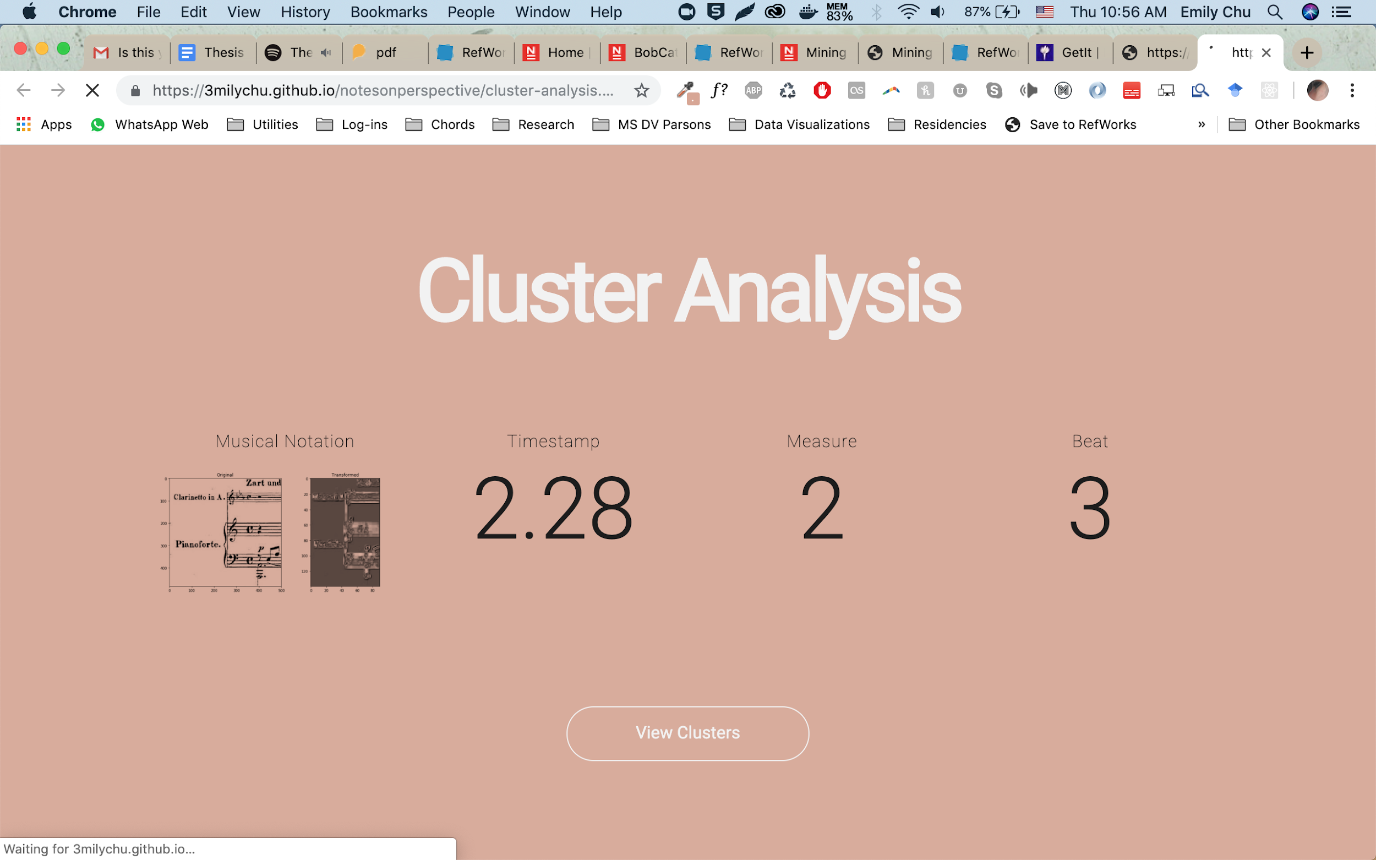

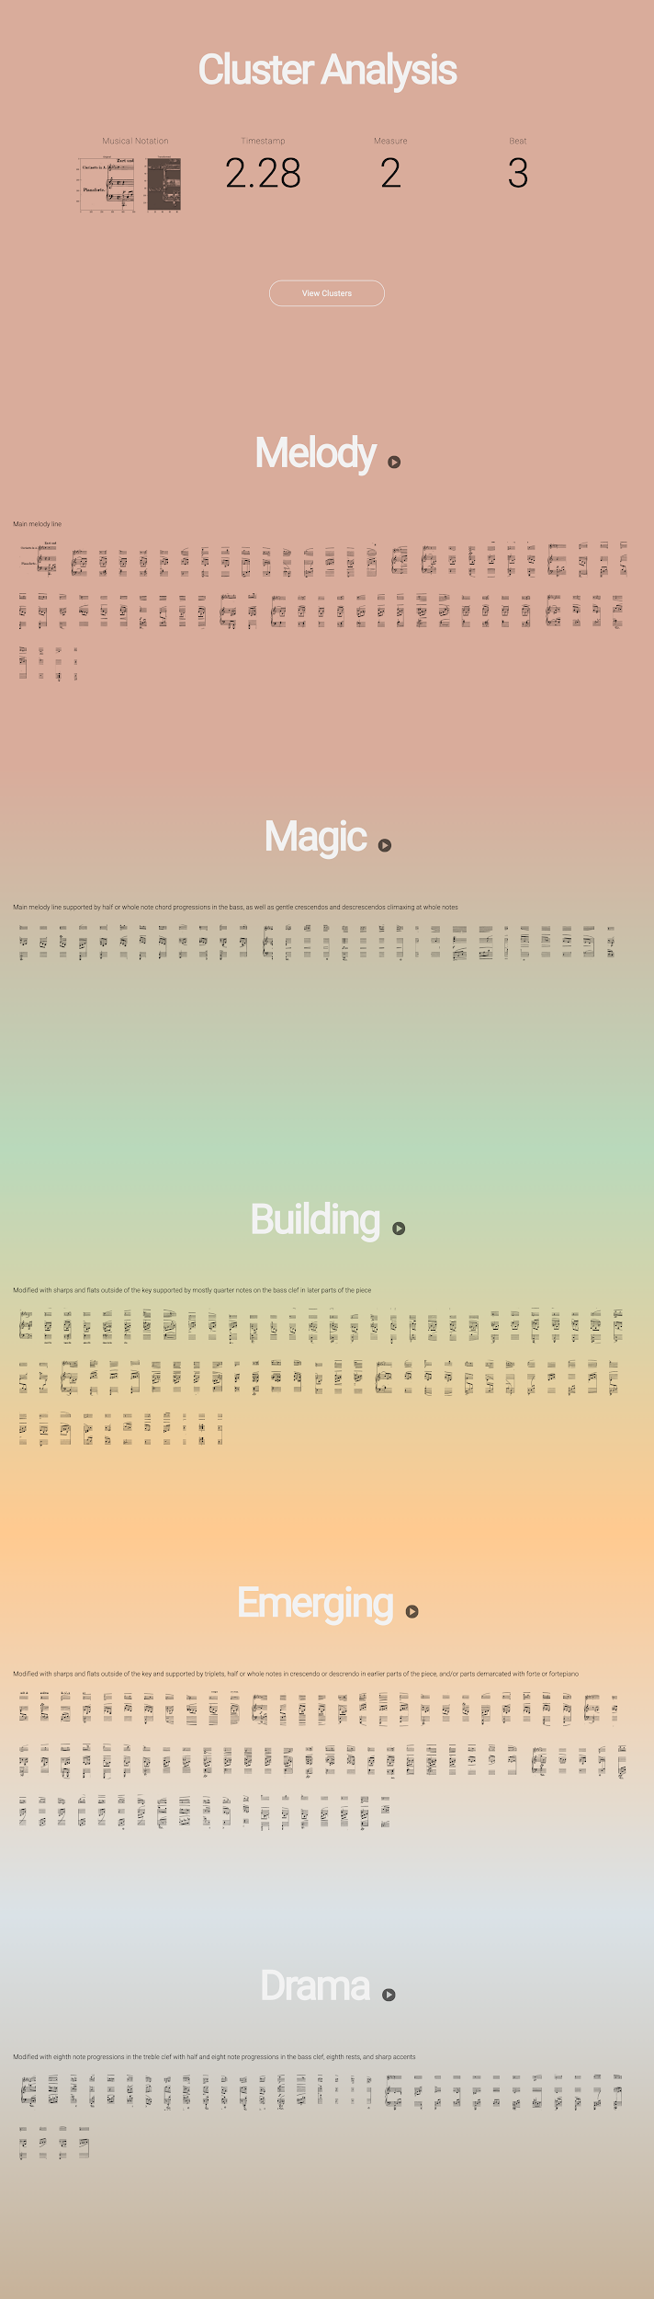



function showClusters(data){

cluster0 = data.filter(function(d){return d.labels==0})

cluster1 = data.filter(function(d){return d.labels==1})

cluster2 = data.filter(function(d){return d.labels==2})

cluster3 = data.filter(function(d){return d.labels==3})

cluster4 = data.filter(function(d){return d.labels==4})

getCluster(cluster0, 0)

getCluster(cluster1, 1)

getCluster(cluster2, 2)

getCluster(cluster3, 3)

getCluster(cluster4, 4)

function getCluster(cluster, num){

target = document.querySelector('body')

div = document.createElement('div')

div.setAttribute("class","cluster")

h1 = document.createElement('h1')

if(num==0){

name = 'Melody'

} else if (num ==1){

name = 'Magic'

} else if (num ==2){

name = 'Building'

} else if (num == 3){

name = 'Emerging'

} else if (num == 4){

name = 'Drama'

}

div.setAttribute('id', name)

h1.innerHTML=name

play = document.createElement('div')

play.setAttribute("class", "play")

play.innerHTML="<i class='material-icons'>play_arrow</i>"

identity = document.createElement('img')

identity.setAttribute("class","identity")

identity.src ="assets/images/cluster"+num+".png"

p = document.createElement('p');

p.innerHTML=descriptions[num][0]

content = document.createElement('div')

content.setAttribute("class","content")

for(i=0;i<cluster.length;i++){

holder = document.createElement('div')

holder.setAttribute('id', 'beat'+cluster[i]['img'])

holder.setAttribute('class', 'holder')

img = document.createElement('img')

img.src="assets/cropped/500w/"+cluster[i]['img']+".png"

holder.appendChild(img)

content.appendChild(holder)

}

// div.appendChild(identity)

h1.appendChild(play)

div.appendChild(h1)

div.appendChild(p)

div.appendChild(content)

target.appendChild(div)

}

playAudioSprite();

playClusterScore();

}

**Activity View Display**

*Design Element*

The Relative time vs. Absolute time toggle demonstrates time expansion or contraction based on amount of activity. When there are more reactions in a given moment of the performance, the playback rate speeds up or slows down by an ordinal classification of:

* 0 comments: very fast (2.5x original time)
* 1 comment: fast (2x original time)
* 2 comments: normal (1x original time)
* 3+ comments: slow (0.6x original time)

*Design Research*

Musical experience, among other experiences such as meditation and sensory deprivation, induces time modulation that modifies the sense of ego and self (Wittmann 2015, 172-181). Since slower passage of time, or time expansion, is associated with a feeling of presence, when there are more reactions in a given moment, this was interpreted as the ensemble class members paying more attention and being more present in the moment, therefore the playback rate is slowed down accordingly (Wittmann 2015, 172-181). While “positive emotions such as the feeling of awe….[also] evokes an update of one’s mental schema and leads to the feeling of time expansion” (Wittmann 2015, 172-181), adjusting playback rate based on negative or positive sentiment was not designed for to simplify the user experience. For a breakdown of aspects of experience that modify time, refer to the table below (Wittmann 2015, 172-181).

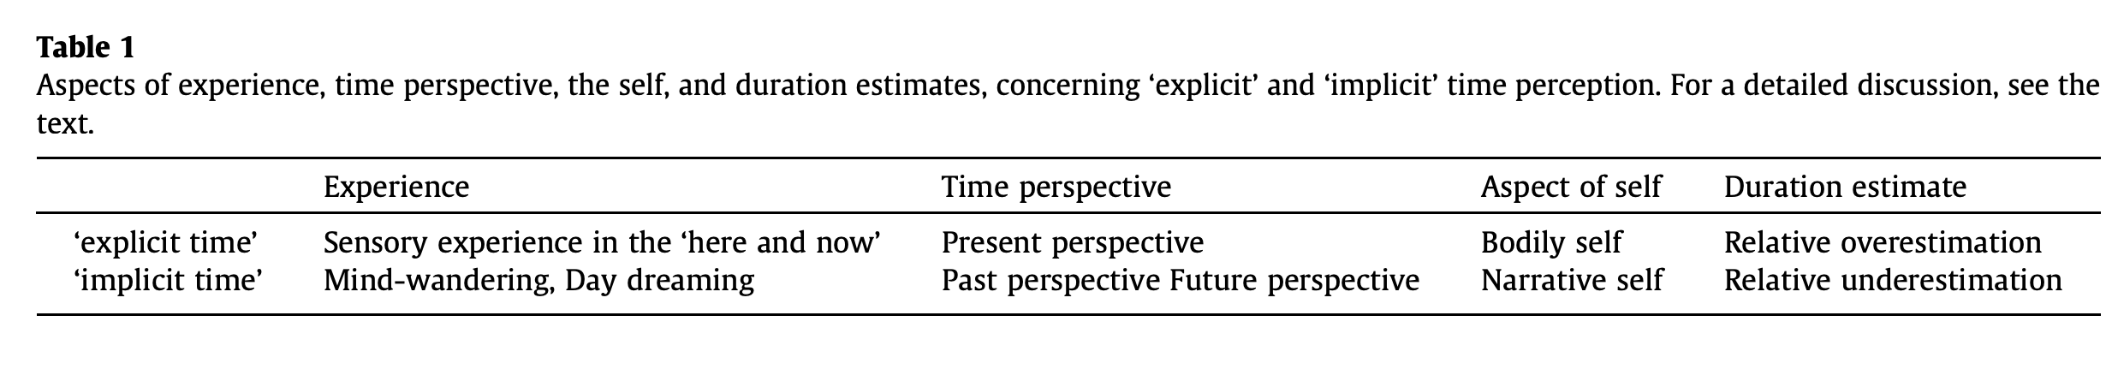

*Execution*

// adjust audio playback rate based on # reactions

function adjustPlayback(data) {

slow=0.6;

normal=1;

fast=2;

veryfast=2.5

if(data.length==0){

audio.playbackRate = veryfast;

} else if(data.length==1){

audio.playbackRate = fast;

}else if (data.length>1 && data.length <3){

audio.playbackRate = normal;

} else {

audio.playbackRate = slow;

}

}

**Activity View Display**

*Design Element*

The activity view display borrows from popular social media conventions to offer easy access to the raw data behind the data visualization. As the audio of the performance plays, the timestamp is continually checked against the reaction data to see if there are any reactions that occur in that moment. If there is, a function to get the reactions is executed.

*Design Research*

Notes on Perspective follows Khrouf et.al’s perspective in developing the application EventMedia, which mines events’ connections on the social web. The visualization of “distributed data fragments provides a key advantage not only to deliver enriched views, but also to gain insight into interesting sociological aspects. [The] goal is to build a web-based environment that allows users to discover meaningful, surprising or entertaining connections between events, media and people (Khrouf, Milicic, and Troncy 2014, 3-10).” To achieve this in context of the musical performance under visualization, Notes on Perspective pops up reaction data as comments in time to the performance, allowing interactors to focus on the connection between musical moments and particular thoughts and feelings experienced by the professional musicians in the study.

*Execution*

// get reactions

function getReactions(data){

// display reactions

clear();

data = updateData(data);

add= data.filter(function(d){

return ((parseInt(d.MOM_STARTBAR+d.MOM_STARTBEAT) <= ref.value) &&

(parseInt(d.MOM_ENDBAR+d.MOM_ENDBEAT) >= ref.value));

})

// add reaction comments

addComments(add);

}

**Activity View Comment Tags**

*Design Element*

Each reaction displayed as a comment is tagged with the musical subject matter which best describes that reaction (there may be multiple) i.e. dynamics, balance, tempo, timing, etc. These tags are generated by checking against the reaction data against category fields for each reaction in a given moment. Any tag that is associated with a reaction is sent to an array along with the value (positive or negative sentiment) that describes the felt nature of that tag. In execution, I iterate through the array and append a set of DOM elements which display color-coded tags by sentiment to the corresponding comment element.

*Design Research*

To gain insight into high volumes of real-time social data streams, Maynard et.al proposes a semantic annotation and querying process for visualization (Maynard et al. 2017). Notes on Perspective selected two components from Maynard’s semantic analysis pipeline to visualize: topic detection and sentiment analysis (Maynard et al. 2017).

*Execution*

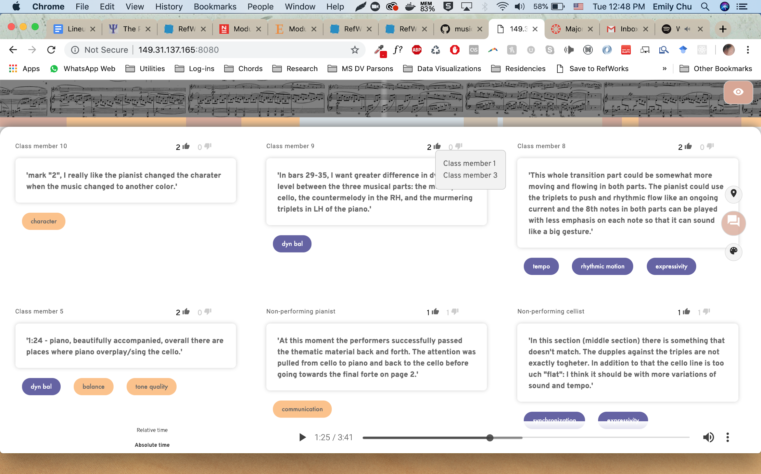

function displayTags(data, comment_id){

tags = []

categories=['dynamics', 'dyn_bal', 'balance', 'tempo', 'timing', 'character','rhythmic_motion',

'synchronization', 'communication', 'matching_musical_idea', 'expressivity',

'tone_quality', 'ending'];

for(i=0;i<categories.length;i++){

category = categories[i];

if(data[category]!=undefined && data[category]!= ""){

category2 = category.replace(/_/g, " ")

tags.push({

tag: category2,

sentiment:data[category]

});

}

}

for(i=0;i<tags.length;i++){

category_tag = document.createElement('div');

category_tag.setAttribute("class", "tag");

category_tag.setAttribute("value",tags[i]['sentiment'] )

category_tag.innerHTML=tags[i]['tag'];

target = document.getElementById(comment_id);

target.appendChild(category_tag);

}

}

**Activity View Agreements & Disagreements**

*Design Element*

Agreements and disagreements, an indication of shared endorsement or difference of opinion as the object of observation in the research study, are displayed as number of likes or dislikes next to the comment. Hovering over the like or dislike count reveals who endorsed or differed in opinion.

*Design Research*

A basic tracking metric used in social media, especially to analyze data by ranking and sentiments (such as positive and negative remarks), is that of number of likes or dislikes, which can be expressed explicitly, through thumbs up and down, or other emoticons (Singh 2017, 1515-1526). Notes on Perspective uses this devices to demonstrate the level of shared agreement for any reaction that occurs throughout the performance.

*Execution*



function endorsementsDetail(data) {

tooltip=document.querySelector('.tooltip');

agrees = document.querySelectorAll(".agree");

disagrees = document.querySelectorAll(".disagree");

for (i=0;i<agrees.length;i++){

agrees[i].onmouseover=function() {

agree = [];

disagree = [];

getpos();

tooltip.style.left=x;

tooltip.style.right="auto";

tooltip.style.top=y;

comment_id = this.getAttribute("name");

index = data.findIndex(obj => obj.comment_id==comment_id);

if(parseInt(data[index]['rater1_reassigned'])<3){

disagree.push(data[index]['rater1'])

} else {

agree.push(data[index]['rater1'])

}

if(parseInt(data[index]['rater2_reassigned'])<3){

disagree.push(data[index]['rater2'])

} else {

agree.push(data[index]['rater2'])

}

displayEndorsement();

function displayEndorsement() {

if(agree.length!=0){

tooltip.style.display="block";

tooltip.style.opacity="1";

tooltip.innerHTML="";

for(j=0;j<agree.length;j++){

tooltip.innerHTML+="<div>"+agree[j]+"</div>"

}

}

}

}

agrees[i].onmouseout=function() {

tooltip.style.display="none";

tooltip.style.opacity="0";

}

}

for (i=0;i<disagrees.length;i++){

disagrees[i].onmouseover=function() {

agree = [];

disagree = [];

getpos();

tooltip.style.left=x;

tooltip.style.right="auto";

tooltip.style.top=y;

comment_id = this.getAttribute("name");

index = data.findIndex(obj => obj.comment_id==comment_id);

if(parseInt(data[index]['rater1_reassigned'])<3){

disagree.push(data[index]['rater1'])

} else {

agree.push(data[index]['rater1'])

}

if(parseInt(data[index]['rater2_reassigned'])<3){

disagree.push(data[index]['rater2'])

} else {

agree.push(data[index]['rater2'])

}

displayEndorsement();

function displayEndorsement() {

if(disagree.length!=0){

tooltip.style.display="block";

tooltip.style.opacity="1";

tooltip.innerHTML="";

for(j=0;j<disagree.length;j++){

tooltip.innerHTML+="<div>"+disagree[j]+"</div>"

}

}

}

}

disagrees[i].onmouseout=function() {

tooltip.style.display="none";

tooltip.style.opacity="0";

}

}

}

**Situated View: Meet the Ensemble**

*Design Element*

In the situated view, participants are invited to meet the Ensemble class to personalize the humans driving the activity that are abstracted and visualized in all other aspects of the data visualization. To invoke a sense of personal identification and understanding of ensemble members as personalities, tooltips are offered to provide a view into personal details regarding their familiarity with the piece, the instruments they play, as well as random thoughts that refresh upon each new “encounter” (hover) over that ensemble member.

*Execution*

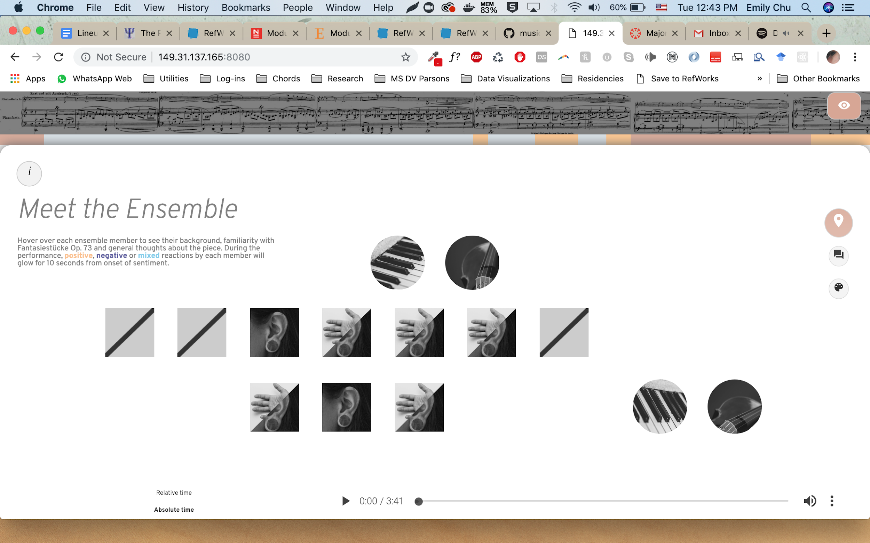

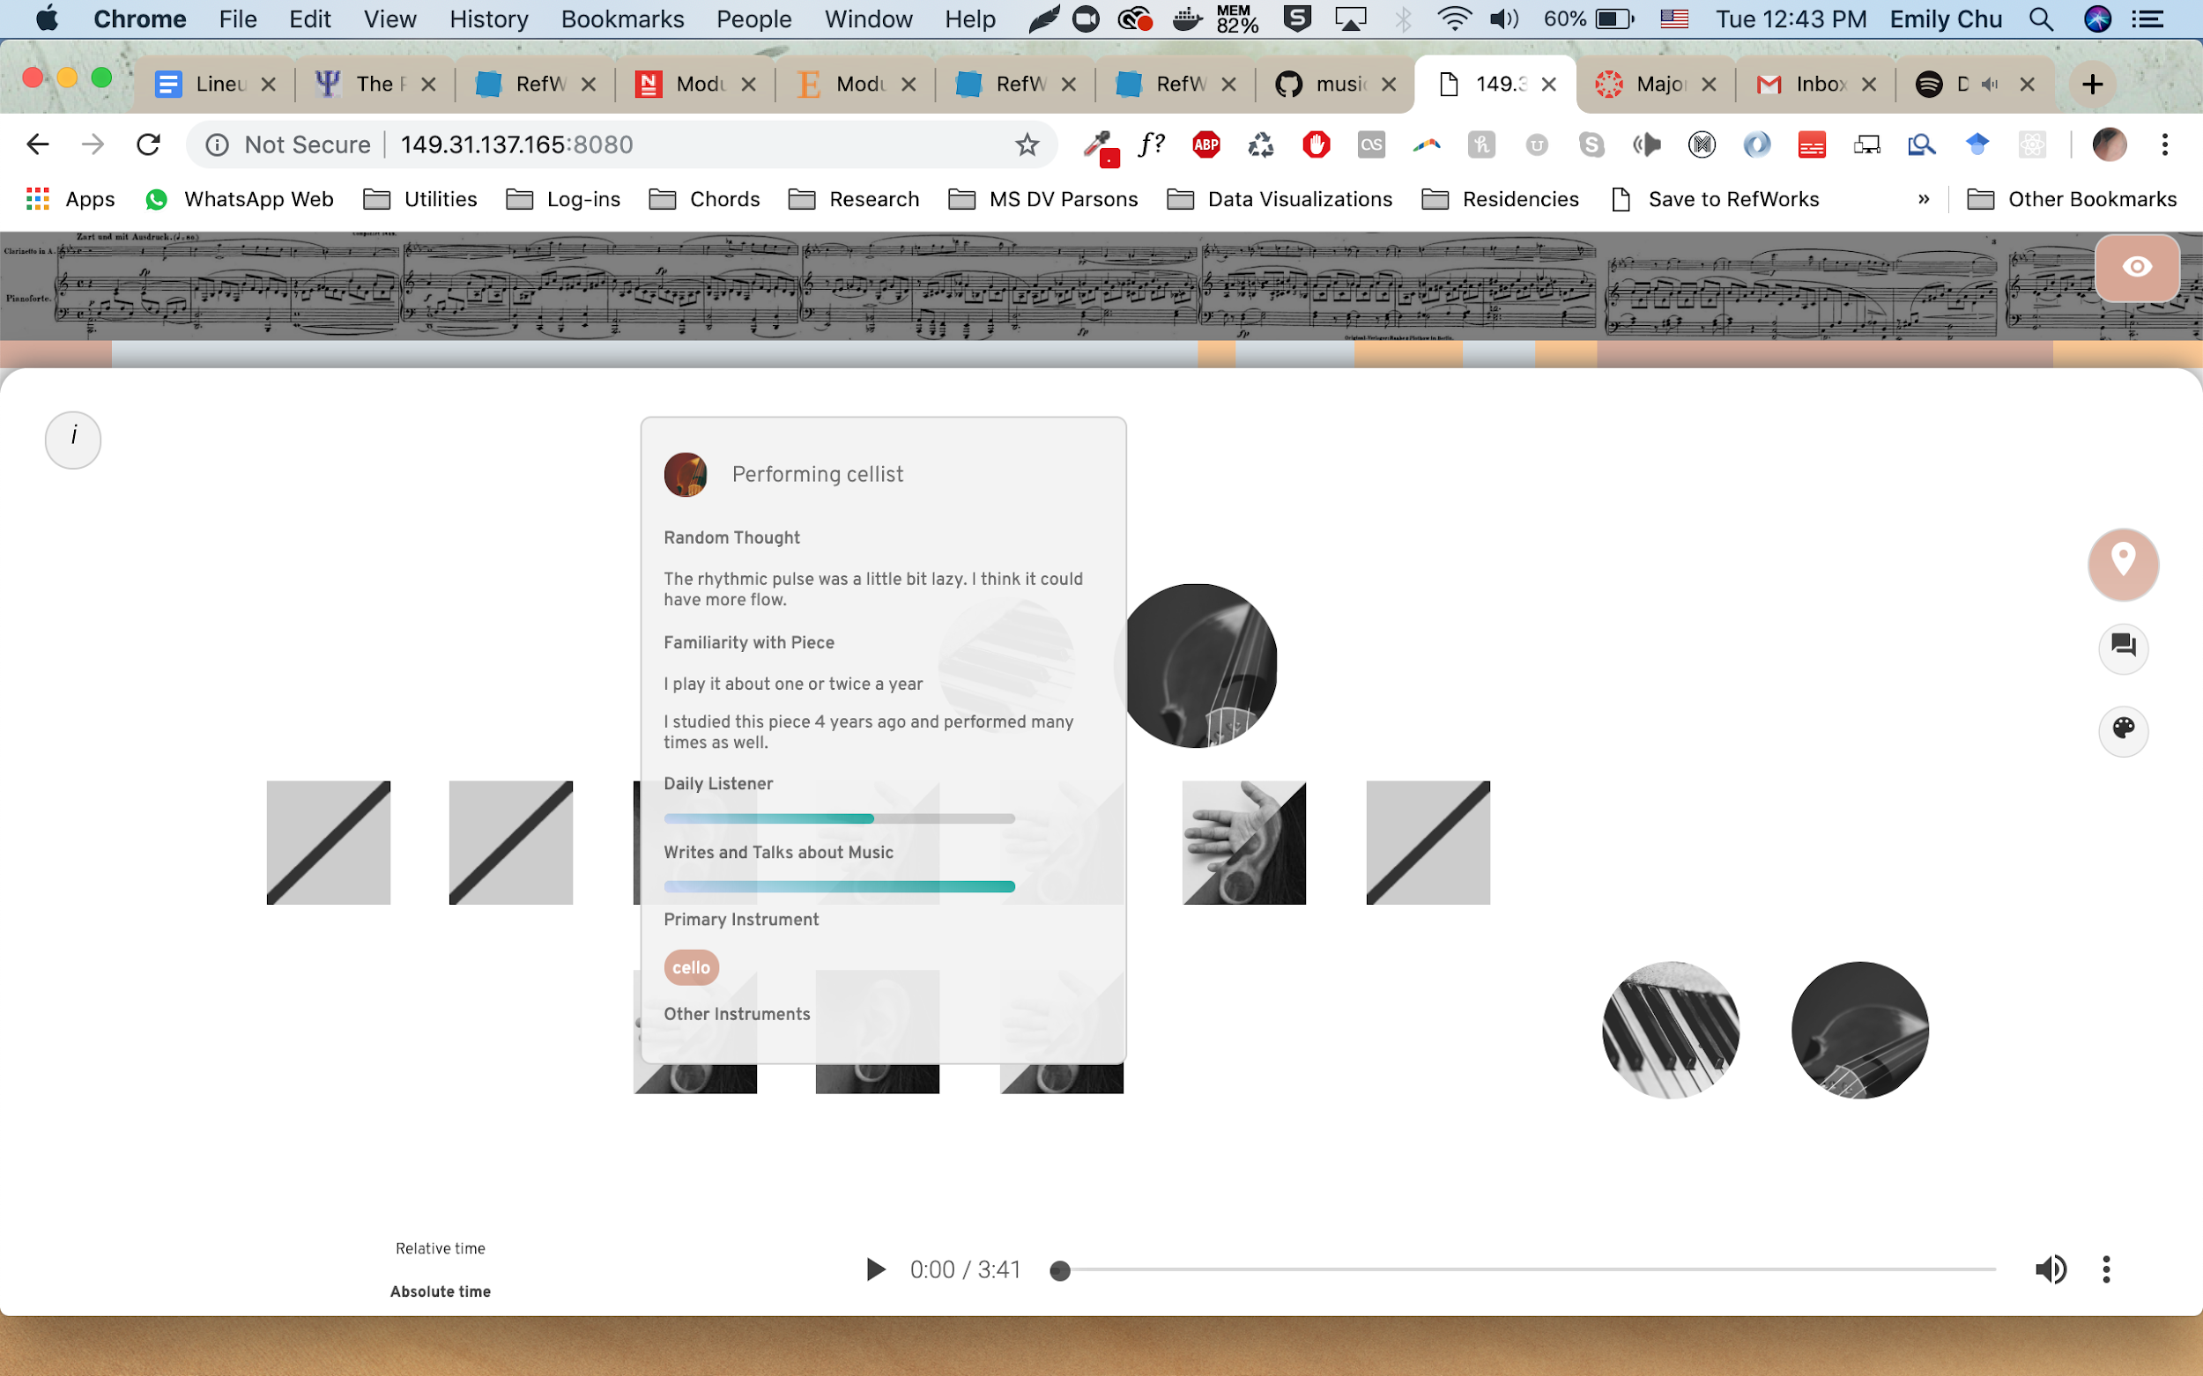

function getProfileData(data, role){

target = document.querySelector('.profile')

role = caps(role.replace(/_/g, " "))

data = data.filter(function(d){return d.role== role});

summary1 = data[0]['summary1']

summary2 = data[0]['summary2']

summary3 = data[0]['summary3']

heard = data[0]['heard']

if (heard != "no"){

heard_bool = "yes"

} else {

heard_bool = "no"

}

played = data[0]['played']

if(played == "no"){

played_bool = "no"

} else {

played_bool = "yes"

}

if (role.match("pianist")){

pic = "pianist"

} else if (role.match("cellist")){

pic = "cellist"

} else if (role.match("Class member")){

if(heard_bool=="yes" && played_bool == "yes"){

pic = "both"

} else if (heard_bool == "no" && played_bool == "no"){

pic = "none"

} else if (heard_bool == "yes"){

pic = "heard"

} else if (played_bool == "yes"){

pic = "played"

}

}

getDetails(data, target, pic, role)

tooltip.style.display="block";

tooltip.style.opacity="0.95";

}

function getDetails(data, target, pic, role){

formatPercent = d3.format(".0%")

listendaily = data[0]['q5_listendaily']

console.log(listendaily)

critique = data[0]['q6_talkwrite']

primary_instrument = data[0]['q7_instr_primary'].split(",")

all_instruments = data[0]['q8_instr_all'].split(",")

play_genres = data[0]['q9_play_genres']

listen_genres = data[0]['q10_listen_genres']

gender = data[0]['gender']

ethnicity = data[0]['ethnicity']

education = data[0]['education']

random = (Math.floor(Math.random() * 3) + 1).toString()

random = "summary" + random;

profile_pic = "<div class='profile-pic "+ pic + "'></div>"

target.innerHTML+= "<div class=top>" + profile_pic + "<h2>"+ role + "</h2></div>"

target.innerHTML+="<h2>Random Thought</h2><p>"+ data[0][random] + "</p>"

target.innerHTML+="<h2>Familiarity with Piece</h2>"

if(data[0]['played']!="no" || data[0]['heard']!="no"){

if(data[0]['played']!="no"){

text = data[0]['played'].split("Yes, ");

target.innerHTML+="<p>"+text[1]+"</p>"

}

if(data[0]['heard']!="no"){

text2 = data[0]['heard'].split("Yes, ");

target.innerHTML+="<p>"+text2[1]+"</p>"

}

} else {

target.innerHTML+="<p>"+"No prior familiarity with the piece"+"</p>"

}

target.innerHTML+="<h2>Daily Listener</h2>"

target.innerHTML+="<div style='width:80%;height:0.5em;background-color:#CCCCCC;border-radius:2em;overflow:hidden;'><div style='background:linear-gradient(15deg, #D9DFFF, #00A99A);border-radius:2em;height:0.5em;width:"+formatPercent(listendaily/5)+"'></div>"

target.innerHTML+="<h2>Writes and Talks about Music</h2>"

target.innerHTML+="<div style='width:80%;height:0.5em;background-color:#CCCCCC;border-radius:2em;overflow:hidden;'><div style='background:linear-gradient(15deg, #D9DFFF, #00A99A);height:0.5em;border-radius:2em;width:"+formatPercent(critique/5)+"'></div>"

target.innerHTML+="<h2>Primary Instrument</h2>"

target.innerHTML+="<tag>" + primary_instrument[0].trim() + "</tag>"

target.innerHTML+="<h2>Other Instruments</h2>"

if(all_instruments!=""){

for(j=0;j<all_instruments.length;j++){

instrument = all_instruments[j].trim();

console.log(instrument);

target.innerHTML+="<tag>"+instrument+"</tag>"

}

}

}

**Situated View: Sentiment Glow Animation**

*Design Element*

In the situated view, ensemble class members are represented as squares that glow for a certain amount of time from onset of sentiment. This was designed to emulate a MIDI pad, creating a rhythm or beat of sentiments that occur throughout the performance. Pulsating MIDI squares represent that that person is continually experiencing that sentiment for the duration of the pulsation; fading sentiments represent a thought that occured in a moment and passes. Sentiment is encoded by color based on the legend: 1) Gold = Positive sentiments, 2) Violent = Negative sentiments, 3) Blue = Mixed or neutral sentiments

*Design Research*

“Bodily signals could function as ‘pulses’ accumulating steadily when attention is directed to time and thus modulating subjective duration (Wittmann 2015, 172-181) ”. Based off of this theory, for reaction data that spans across multiple beats in succession, the MIDI square sentiment glow linked to that comment pulses or fades accordingly.

*Execution*

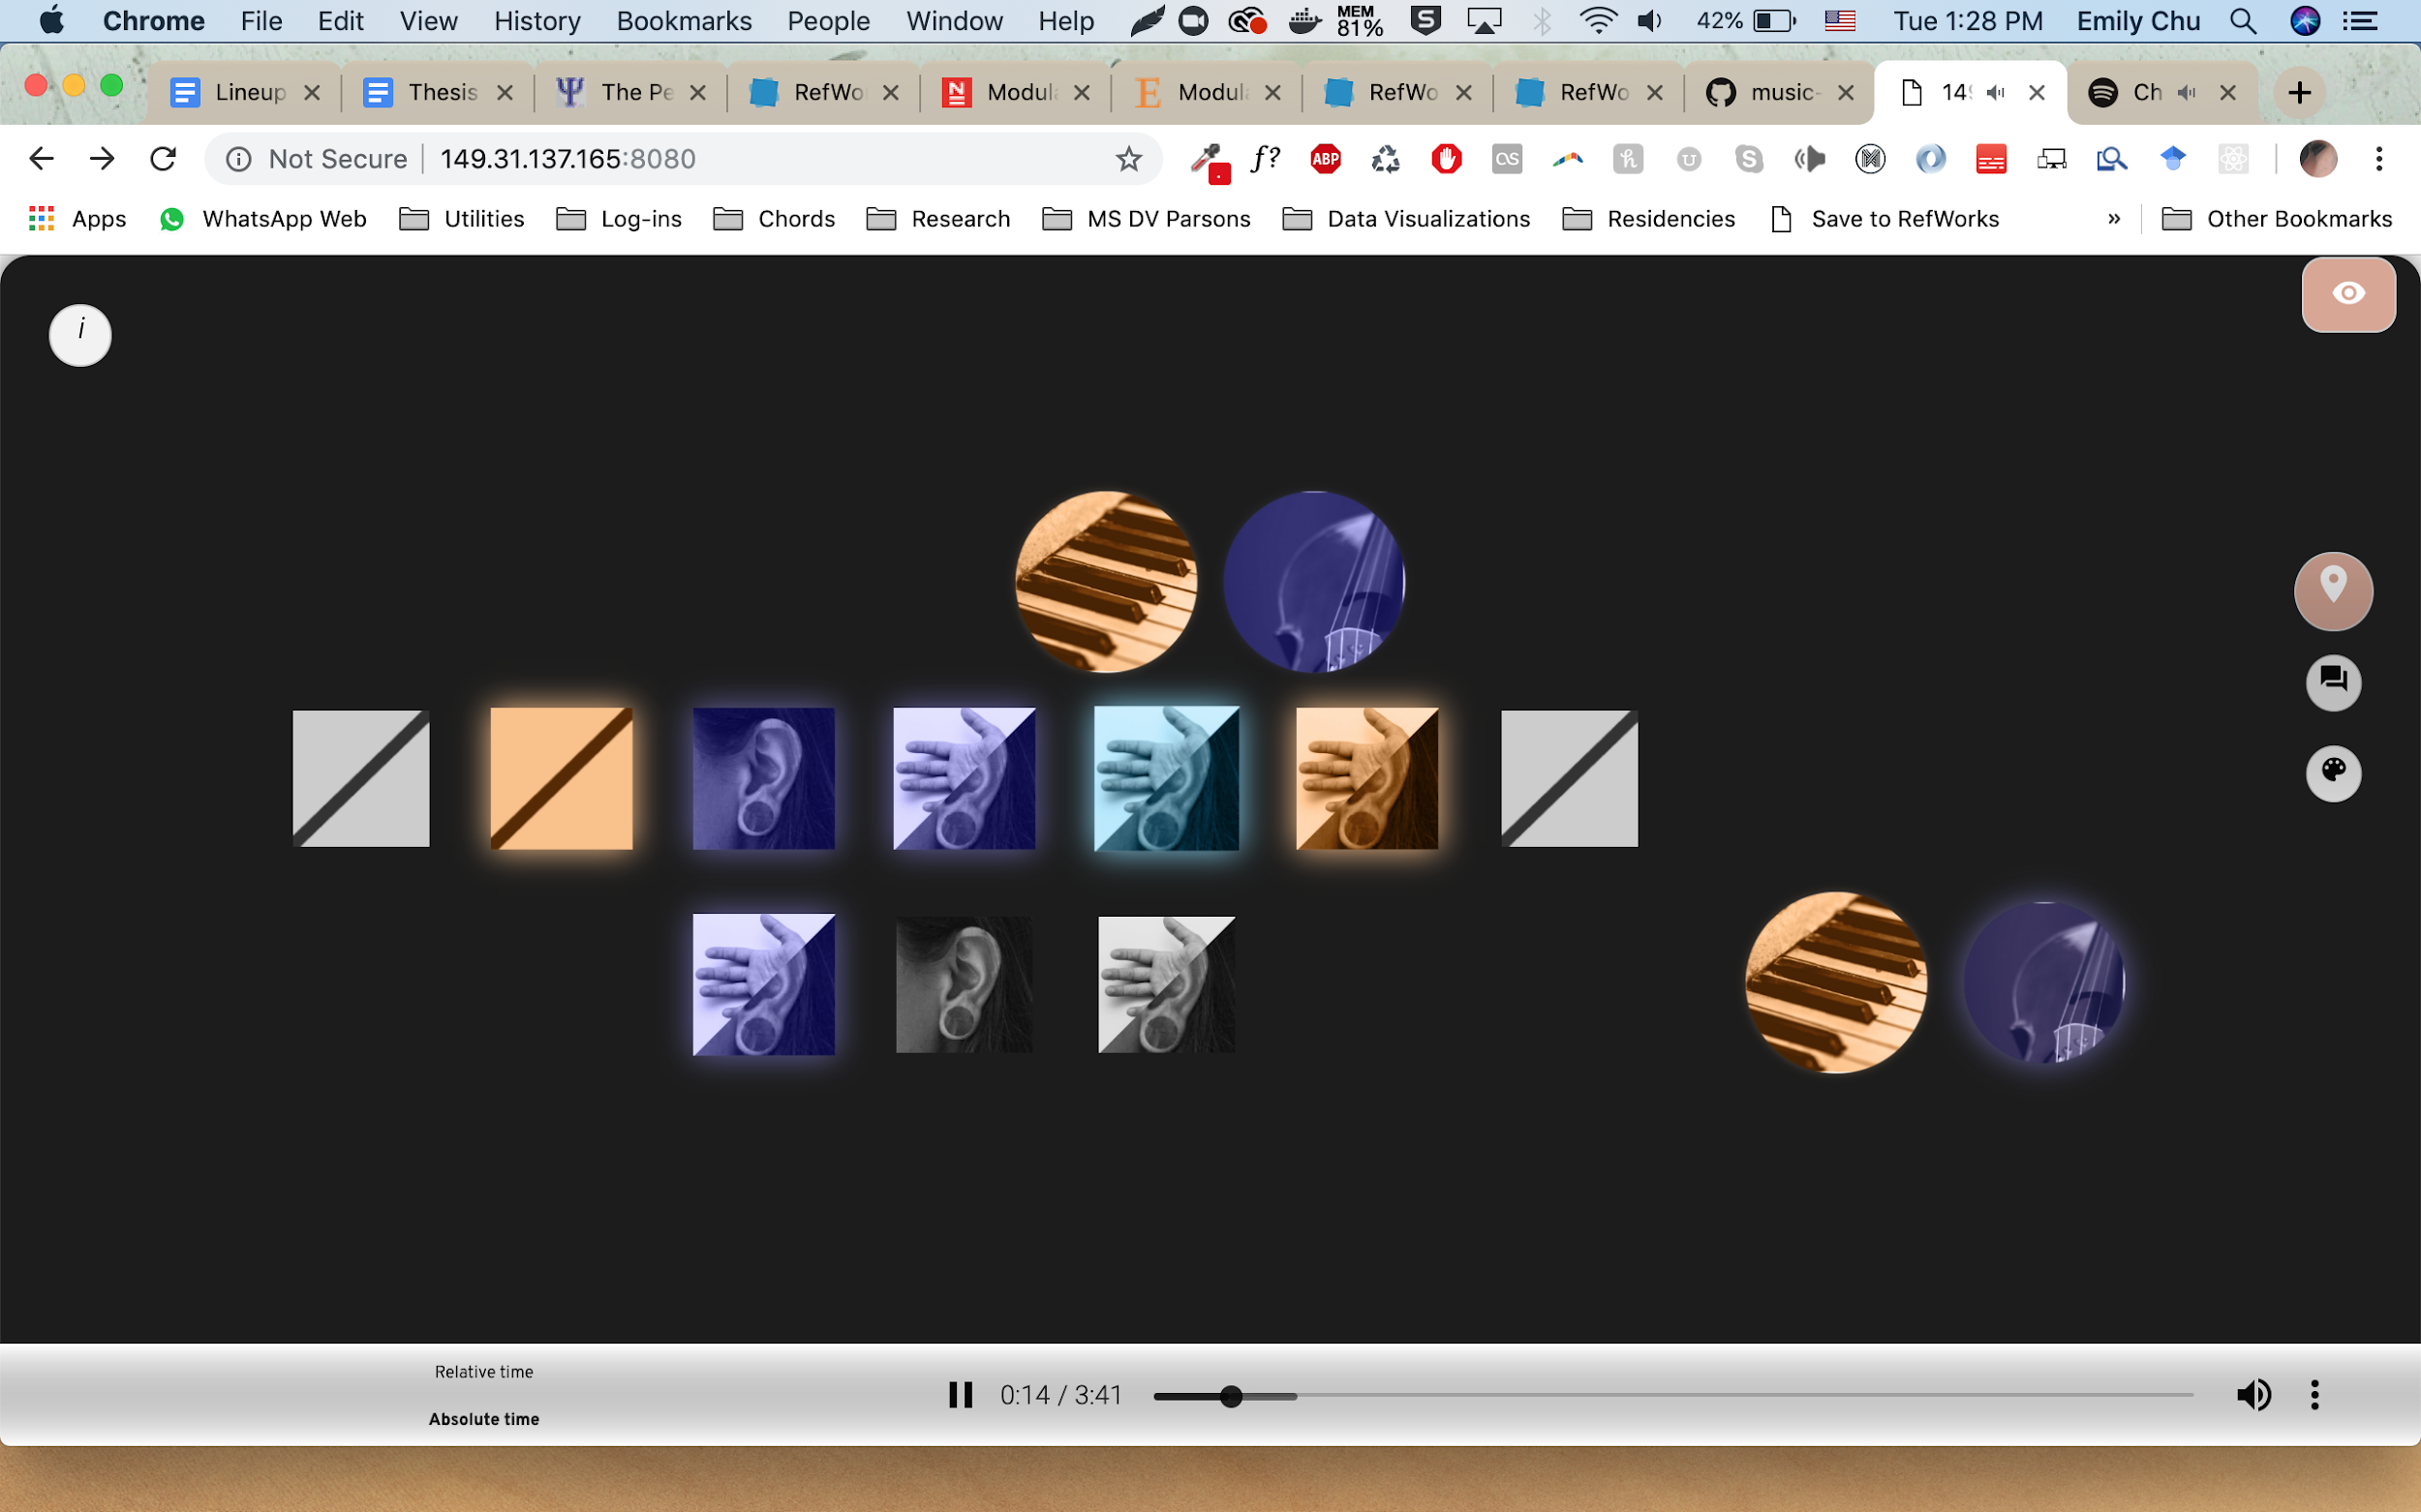

**Situated View: Theatre Lighting**

*Design Element*

In the situated view, the lights emulate the darkening of a theatre to situate the participant in the space in which the original humans who generated the data.

*Execution*



**Perception View Design Elements**

Based on the multiplicity of design elements used in the Perception view to draw an “Impression” for each moment of the performance, the details for each element is condensed into a single summary explanation.

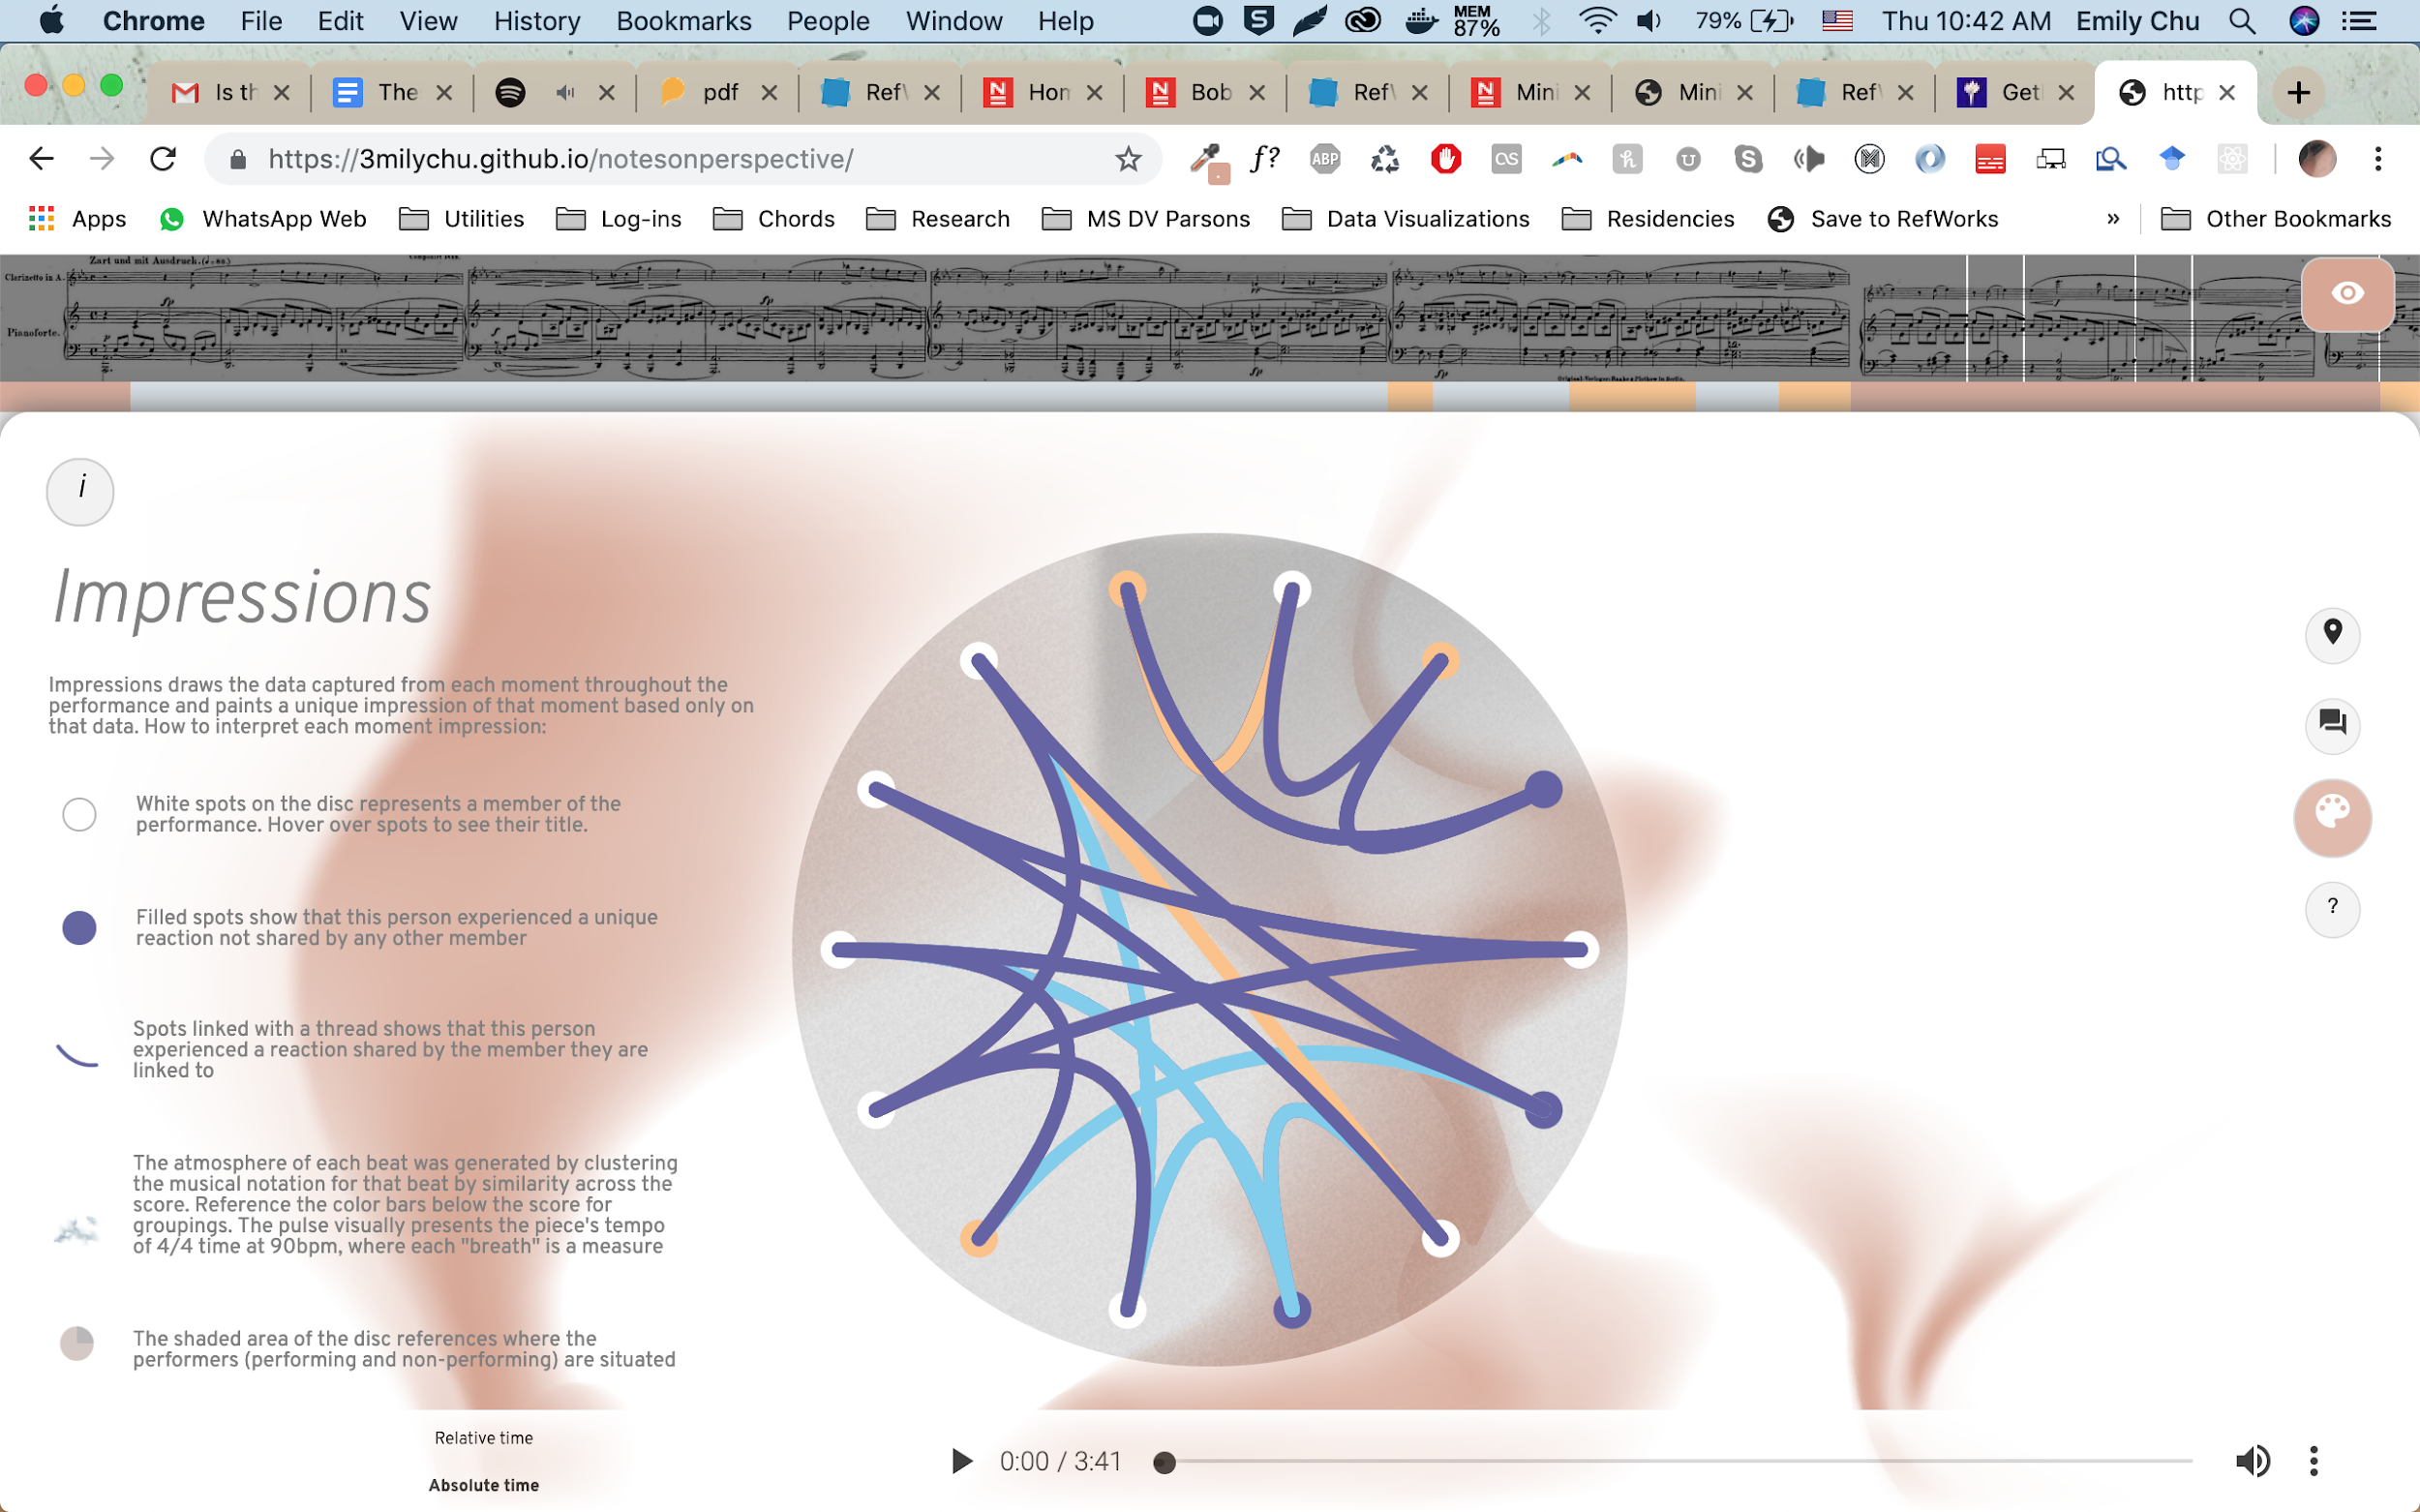

*Disc*

The spinning disc was inspired by a record player spinning. It spins when the performance is playing. White spots on the disc designate slots for each of the ensemble members present; a callout to the encoded relationship between recorded event and attendees of the original event.

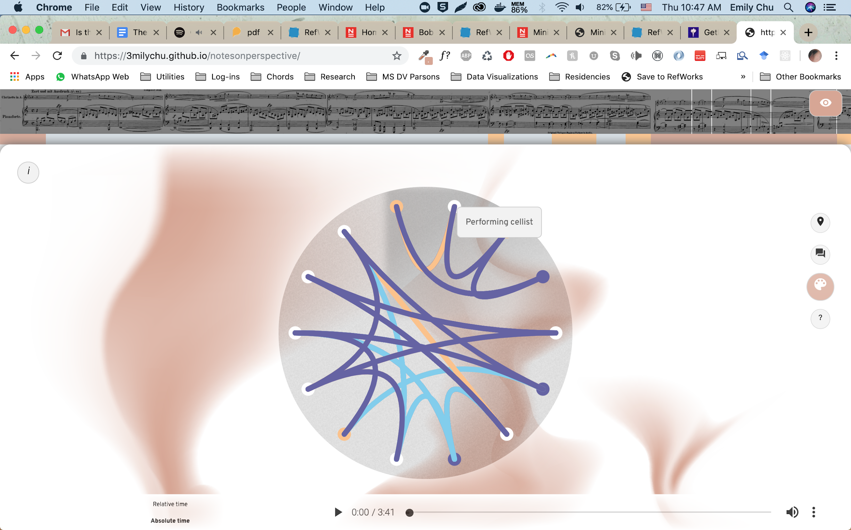

*Filled spots*

Filled spots signify disagreement on the part of that ensemble member, also defined as a reaction that differed from any other ensemble member in that point in time.

*Threads*

“William James for example, although he did not actually assert that a form was a sensation...believed that a visual line was a simple datum rather than a row of point sensations (Gibson 1974)”. Threads represent agreement between the two members connected by the thread. The color of the thread follows the same sentiment color encoding previously described.

Hovering over a thread reveals the comment that is being agreed upon.

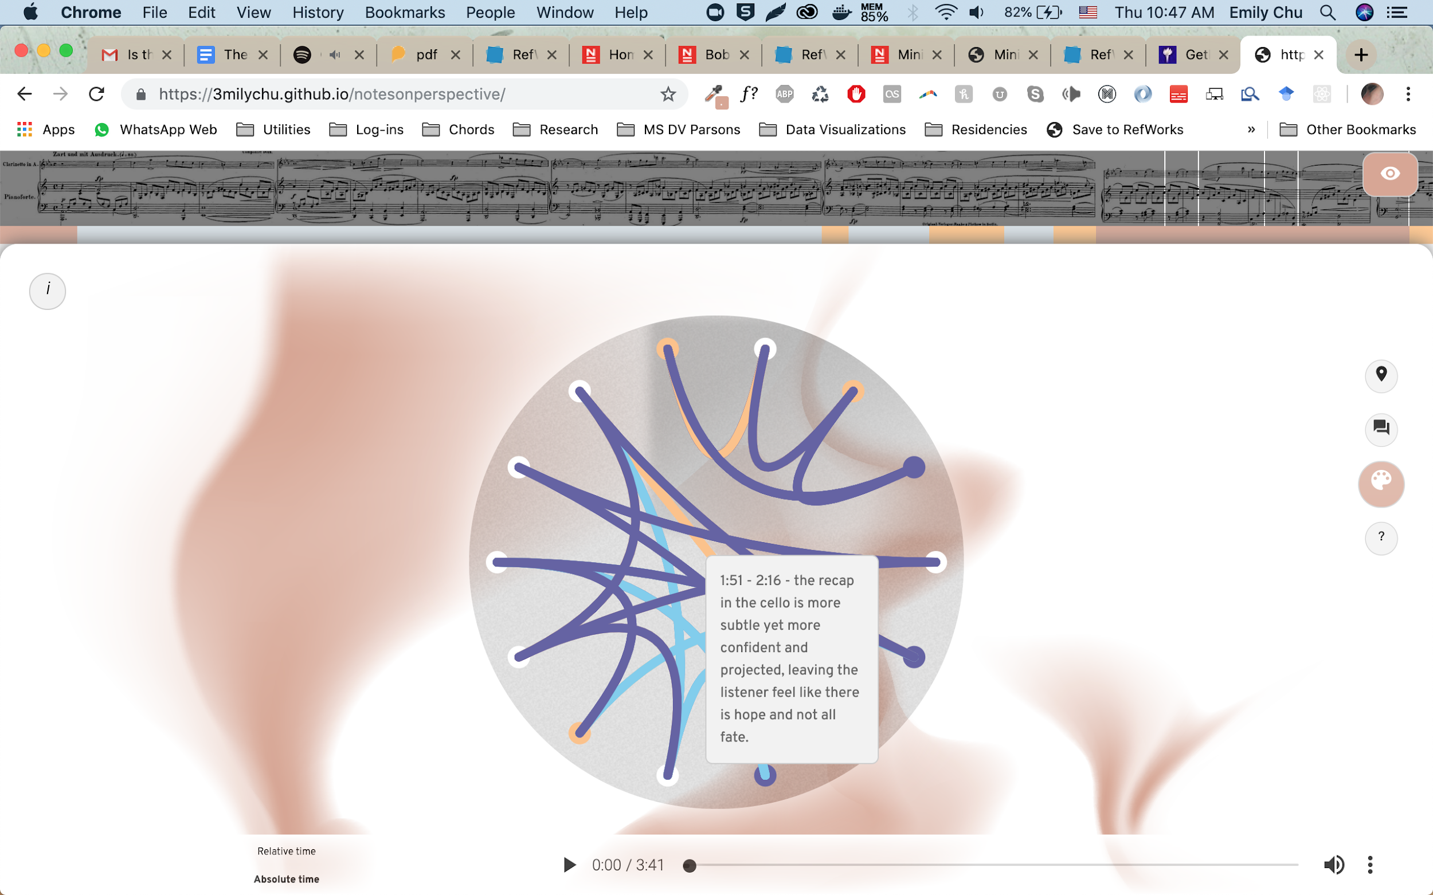

*Background breath animation*

Each Impression’s background “breathes” to the intended time of the original score: 4/4 time at 90 beats per minute (bpm). Each inhale and exhale were matched to this tempo to represent the passing of one measure. This was done to induce an experience of embodied time in the viewer. The thought is that since intentional breathing has shown to slow heart rate to that pace, and “conscious awareness of the own heart beat…[is] also related to time perception accuracy (Meissner & Wittmann, 2011), by animating the visual representation of the music, we are encouraging the participant to embody the invisible sense data which typically cannot normally be felt during musical performances unless there is a metronome ticking along, which is the absolute time of the piece (Modulations of the experience of self and time).”

#### Limitations and Continuing Research

### Issues and Limitations of Visualizing Kairos

Major current issues and limitations of visualizing temporal data as an embodied visualization are:

**The hegemony of absolute, measured time**

Time has been standardized by absolute measures, including the calendar and the clock, into accepted divisions, such as years, months, days, hours, minutes, seconds, milliseconds and so on (West-Pavlov 2013). To understand anything within our framework of time, the way we read Chronos must be present in all visualizations of Kairos in some way to “understand where we are”.

**Representations of absolute, measured time**

Despite the indisputable hegemony of absolute, measured time - data visualizations have experimented with representations of absolute measured time beyond those characterized by a standardized “horizontal mental time line”.

**Narrative as the gateway of time**

Ricoeur says, “narrative as the guardian of time” and “there can be no time but narrated time” (West-Pavlov 2013). To understand data visualized in a kairos space effectively, narrative should be present to facilitate the understanding of essential concepts such as points of view, progression, sequence and becoming.

**Limits in Technology and Development**

This visual study of kairos in data visualization uses the ability to develop web applications, single page applications (SPAs) that individuals can interact with to a limited degree through a screen. The data visualization presented within this web application is limited to what can be represented and interacted with visually or auditory through such means. The success of this project is dependent upon the design choices made by the designer and developer of this project (myself, with the input of peers in my thesis course among others within my accessible community). The development of this project is also limited by the capabilities of the author.

## V. Conclusion

Bibliography

Ajana, Btihaj. 2018. *Metric Culture: Ontologies of Self-Tracking Practices*. First ed. United Kingdom: Emerald Publishing.

Bedford, Christopher. 2005. *Visual Music: Synaesthesia in Art and Music since 1900* College Art Association, Inc.

Bonato, Mario, Marco Zorzi, and Carlo Umiltà. 2012. "When Time is Space: Evidence for a Mental Time Line." *Neuroscience and Biobehavioral Reviews* 36. https://citeseerx.ist.psu.edu/viewdoc/download?doi=10.1.1.703.7921&rep=rep1&type=pdf.

Chirico, Alice, David B. Yaden, Giuseppe Riva, and Andrea Gaggioli. 2016. "The Potential of Virtual Reality for the Investigation of Awe." *Frontiers in Psychology* 7. doi:10.3389/fpsyg.2016.01766. https://www.frontiersin.org/articles/10.3389/fpsyg.2016.01766/full.

Cho, Cecelia Hyunjae. 2018. *A Hole in Space Stitched by Two Screens*. Https://Oss.Adm.Ntu.Edu.Sg/Hyunjae001/a-Hole-in-Space-Stitched-by-Two-Screens/. ntu.edu. https://oss.adm.ntu.edu.sg/hyunjae001/a-hole-in-space-stitched-by-two-screens/.

Galloway, Kit and Sherrie Rabinowitz. "Hole-in-Space". Nov. http://www.ecafe.com/getty/HIS/.

GU Yan-Yan and ZHANG Zhi-Jie. 2012. "The Horizontal and the Vertical Mental Timeline in Chinese Context." . http://en.cnki.com.cn/Article_en/CJFDTOTAL-XLXB201208004.htm.

Khrouf, Houda, Vuk Milicic, and Raphaël Troncy. 2014. "Mining Events Connections on the Social Web: Real-Time Instance Matching and Data Analysis in EventMedia." *Web Semantics: Science, Services and Agents on the World Wide Web* 24: 3-10. doi:10.1016/j.websem.2014.02.003.

Maynard, Diana, Ian Roberts, Mark A. Greenwood, Dominic Rout, and Kalina Bontcheva. 2017. "A Framework for Real-Time Semantic Social Media Analysis." *Web Semantics: Science, Services and Agents on the World Wide Web* 44. doi:10.1016/j.websem.2017.05.002.

Moeller, Christian. "The Expanded Chamber: Scoring the Demix." https://christianmoeller.com., https://christianmoeller.com/The-Expanded-Chamber-Scoring-the-Demix.

Murray, Janet H. 2012. *Inventing the Medium : Principles of Interaction Design as a Cultural Practice* Cambridge, Mass. : MIT Press.

Neault, Michael. "Lightness & Density: The Films of Charles & Ray Eames." Eames Office., last modified -02-21T17:10:56Z, accessed Apr 25, 2019, https://www.eamesoffice.com/scholars-walk/lightness-density-the-films-of-charles-ray-eames/.

Ostrow, Adam. "Photosynth Comes of Age in CNN's Inauguration Coverage." Mashable., last modified Jan 20, accessed Mar 25, 2019, https://mashable.com/2009/01/20/photosynth-inauguration/.

Poast, Michael. 2000. "Color Music: Visual Color Notation for Musical Expression." *Leonardo* 33 (3): 215-221. doi:10.1162/002409400552531.

Port, Robert F. and Timothy Van Gelder. 1995. *Mind as Motion: Explorations in the Dynamics of Cognition* MIT Press.

*A Hole in Space LA-NY, 1980 -- the Mother of all Video Chats.* Directed by Larry Press. 2013.

Santiago, Julio, Juan Lupáñez, Elvira Pérez, and María Jesús Funes. 2007. "Time (also) Flies from Left to Right." *Psychonomic Bulletin & Review* 14 (3): 512-516. doi:10.3758/BF03194099. https://doi.org/10.3758/BF03194099.

Singh, Archana. 2017. "Mining of Social Media Data of University Students." *Education and Information Technologies* 22 (4): 1515-1526. doi:10.1007/s10639-016-9501-1.

Spence, Ian. 2006. "William Playfair and the Psychology of Graphs." *ASA Section on Statistical Graphics*. http://www.psych.utoronto.ca/users/spence/Spence%20(2006).pdf.

Thönes, Sven, Kurt Stocker, Peter Brugger, and Heiko Hecht. 2018. "Is Mental Time Embodied Interpersonally?" *Cognitive Processing; International Quarterly of Cognitive Science* 19 (3): 419-427. doi:10.1007/s10339-018-0857-6.

West-Pavlov, Russell. 2013. *Temporalities*. New York: Routledge.

Wilmer, Celso and Paulo Henriques Britto. 1995. "Color-Encoded Music Scores: What Visual Communication can do for Music Reading." *Leonardo* 28 (2): 129-136.

Wilson, Andrew D. and Sabrina Golonka. 2013. "Embodied Cognition is Not what You Think it Is." *Frontiers in Psychology* 4. doi:10.3389/fpsyg.2013.00058. https://www.frontiersin.org/articles/10.3389/fpsyg.2013.00058/full.

Wittmann, Marc. 2015. "Modulations of the Experience of Self and Time." *Consciousness and Cognition* 38: 172-181. doi:10.1016/j.concog.2015.06.008.